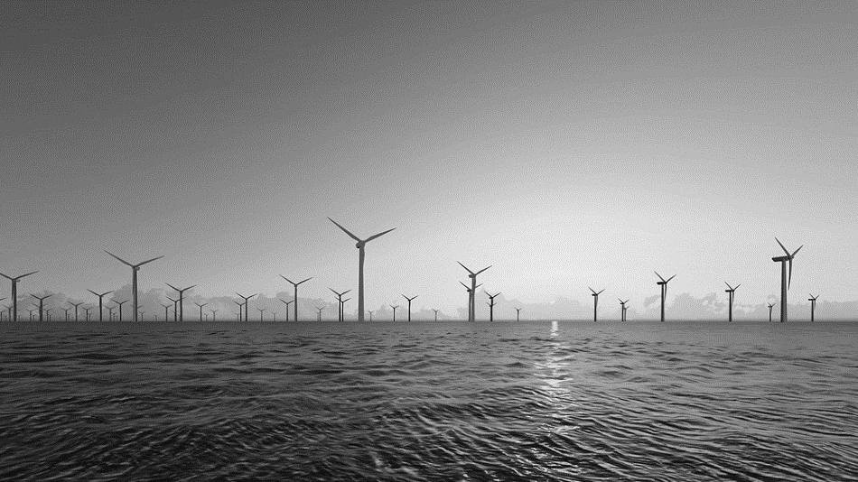

RISK ENGINEERING GUIDELINES
FOR THE INSURANCE OF
FLOATING OFFSHORE
WIND FARMS

ACKNOWLEDGEMENTS:
This document was developed and edited by Daniel Stevens (AXIS Capital, London) with the following contributing authors in alphabetical order:
Bryce Aquino AXIS Capital, London
Jonathan Boutrot Bureau Veritas, Paris
Robert Clark TMC Marine, London
Pilar Heras DNV GL, Copenhagen
George Kallenos ABS, London
Simon Markussen NIORD, Bergen
Pierre-Adrien Opinel AXIS Capital, London
David Watson Canopius, London

The report was reviewed and approved by London market engineers on the Survey and Engineering Sub-Committee within the Joint Natural Resources Committee (JNRC). We are grateful to the members of WFO (World Forum Offshore Wind) for their additional contributions.
The Joint Rig Committee was renamed the JNRC in 2022.
If there are any technical queries regarding this document, please contact the LMA (lma@lmalloyds.com).
DISCLAIMER:
Nothing in this Guideline, which is entirely voluntary, shall relieve any party of any legal obligations existing in the absence of this document and nothing contained in this Guideline shall take precedence over any provisions of any policy issued by a party who has chosen to adopt this Guideline.

DOCUMENT REVISION HISTORY:
Version | Version Notes | Date of Revision
2024/001 | First Publication | 25th October 2024

TABLE OF CONTENTS
Contents

Executive Summary………………………...…………………………………………………..….5
1. Introduction 6
2. Guiding principles 7
3. Certification and Classification…………...………………………………………...……11
4. Design of Mooring System 26
5. Design of Cable System 33
6. Design of Floater 41
7. Design of Wind Turbine 47
8. Floating Offshore Substations 52
9. Marine Warranty Surveyor 57
10. Construction Phase (Onshore Works) 62
11 Construction Phase (Offshore Works) 69
12 Operations and Maintenance 76

Appendix 1 – Loss Scenarios ……………………………………………………………..…..84
Appendix 2 – List of Minimum Information Required From Brokers…………………....…87
Appendix 3 – Abbreviations ……………………..………………………………………..…...89
Appendix 4 – References…………………………………………………………….……...…92

Risk Engineering Guidelines for the insurance of Floating Offshore Wind Farms

Executive Summary
This document has been produced by the Survey and Engineering Subcommittee of the Lloyd’s Market Association’s Joint Natural Resources Committee to provide guidance to project sponsors of Floating Offshore Wind Farms (‘the insured’) on the key areas of interest to risk engineers working for potential insurers of such projects. It contains a summary of the keys areas of interest to risk engineers, and suggested courses of action to mitigate associated concerns via the adoption of what are considered to be best practice engineering approaches. The guideline highlights the need for project sponsors to provide clear evidence that the design, fabrication, construction and operation of each element of the asset has been carefully considered to ensure the level of risk of damage or loss has been minimised as far as practicable. A preference for obtaining independent verification of the above is clearly expressed, via either classification, project certification, or an integration of both. In the absence of such independent verification, the project sponsor shall need to provide that a technology readiness level of 7 or higher (depending on the standard) has been achieved by each component proposed, if they expect to be offered insurance coverage reflective of the technical maturity represented by this level.
Applicable lessons learnt from fixed-bottom offshore wind are detailed throughout, including the need for a robust project construction plan and due consideration for the availability of suitable vessels and ports for the large workload volumes associated with commercial scale deployment of Floating Offshore Wind Turbines (FOWT). Recent experience of carrying out major component exchanges on FOWTs has been brought to bear on the recommendations around operations and maintenance. Existing JNRC guidance pertaining to the role of Marine Warranty Surveyors, mooring integrity monitoring and operational risk surveys has been incorporated herein as well. Input has been provided by three of the world’s foremost independent verification bodies – American Bureau of Shipping (ABS), Bureau Veritas (BV) and Det Norske Veritas (DNV) – as well as the WFO (World Forum Offshore Wind), and editorial feedback provided by a number of brokers active in the London insurance market for offshore wind. The JNRC are grateful to the above contributors.
This guideline is intended to be a ‘live’ document which will be regularly reviewed and updated as the floating wind industry matures, to capture the lessons learned by both insureds and insurers alike.

Introduction
Whilst some 400 MW of FOWF (Floating Offshore Wind Farm) capacity is currently generating power, a sizeable proportion of which benefits from some level of insurance cover, concerns exist within the insurance market over the diversity, novelty and unproven nature of many designs proposed for future installation. This document outlines concerns identified by the insurance market risk engineers and provides guidance to FOWF project sponsors on potential risk mitigants. These mitigants stem from the loss scenarios listed in Appendix 1 which summarise potential outcomes if risks are not adequately addressed and act as a quick reference for the reader. The end of each section summarises the risks, our key concerns and recommended mitigants.
The term ‘insured’ is used to refer to the party seeking (re)insurance, typically the project sponsor and/or developer. The insurer is the party providing (re)insurance to the insured and is referred to in the singular although multiple insurers may be listed on the insurance policy.
Within this document, the floating foundation upon which the Wind Turbine Generator (WTG) sits is referred to as a ‘floater’, including the Transition Piece (TP) if present. The connection of the WTG to the floater is referred to as integration, whereas ‘assembly’ refers to the process of assembling a WTG (for example, the bolting of the nacelle to the top of its tower, a floater, a mooring system and so on). Figure 1 provides an overview of the four most common floater design types at time of writing.
A full list of abbreviations is found in Appendix 3.
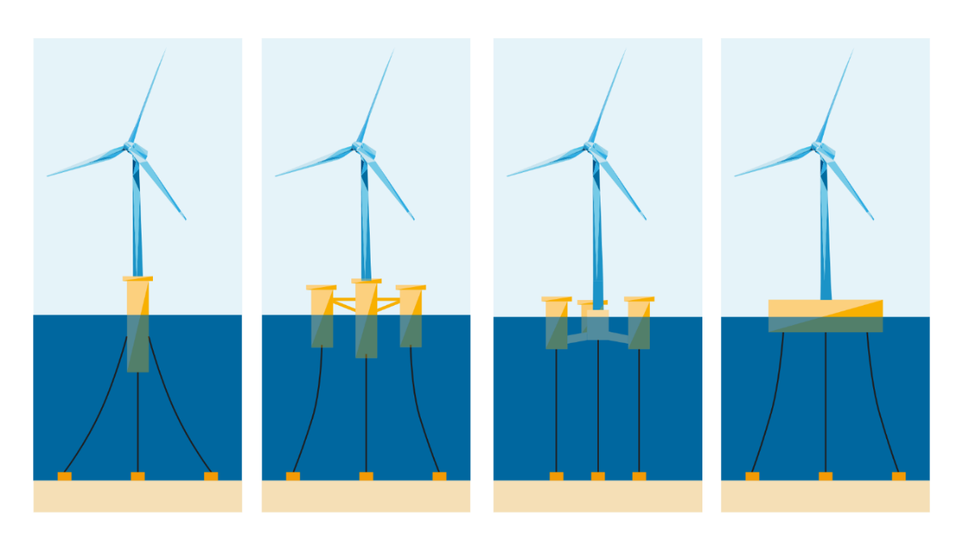
Figure 1: Types of floater design, from left to right: Spar buoy, Semi-Submersible, Tension Leg Platform (TLP), Barge

Guiding principles

2.1 Loss Scenarios
Several loss scenarios based on key project risks were used to inform the scope and structure of this guideline, noting that insurers are usually asked to cover the costs of repairs or replacements (referred to as physical damage or PD costs) as well as the lost revenue resulting from the associated downtime (referred to in the construction phase as either LOPI – loss of production income, or DSU - delay in start-up) and in the operational phase as business interruption BI). A FOWF has a different risk profile to other floating offshore assets such as upstream oil and gas production facilities, which the insurer will consider when considering terms and pricing for insurance cover. A list of the loss scenarios evaluated is located in Appendix 1.
For example, the Estimated Maximum Loss (EML) scenario assumed by insurers for the operational phase of a FOWF typically assumes the loss of all generating capacity for a significant period of time due to the failure of an export cable or, if present, the Offshore Substation (OSS). The cost of the marine spread and critical spares long lead times associated with rectifying such losses drive the EML figure which in turn plays a primary role in the terms and pricing of the insurance cover offered by each (re)insurer. The premium charged reflects the overall risk – both EML and high frequency loss scenarios – which also affects the coverages, wording and deductibles applied.
The next most significant loss scenario is typically the loss of generation from multiple FOWT due to the failure of a bottleneck component such as the power cable or other related component such as an underwater electrical combiner unit. Depending on where the failure occurs this could result in the loss of generation from one WTG at the end of the string, or multiple FOWTs. Serial defects also have the potential to take multiple FOWTs or even the offshore substation offline and specific wording such as serial defect clauses exist for this reason.
FOWF’s may be installed in areas which are subjected to tropical revolving storms (TRS) e.g. east coast US, Japan and Taiwan. The design of the FOWT coupled with the complex dynamic response means that the potential damage to a FOWF is greater than that of an upstream oil and gas facility in the same location. Although the risk of multiple FOWT’s being hit by a TRS is likely to be reduced due to the large distances between FOWTs, a direct hit on the floating offshore substation would constitute a major loss scenario.
Aside from large delays during the construction phase, or widespread damage from a TRS during operations, the need to carry out a Major Component Exchange (MCE) on one or more FOWTs carries the largest potential for a significant claim on a FOW insurance policy. Currently there is a lack of consensus on how different MCE jobs are best executed, reflective of the wide variety in project location, design, vessel and port availability. This guideline offers perspectives on the information required by insurers up front in order to correctly understand the insured’s proposed approach for such MCE work, whether it will be carried out in situ using specialist vessels and cranes, or back at port after towing the floater from the site.

2.2 Insurance Cover assumptions
The following types of insurance policy are considered in the risk scenario analyses that underpin this guideline:
- Construction All Risk (CAR) policies, which typically provides cover for Physical Damage (PD) and the Delay in Start Up (DSU) associated with this damage. The damage may take the form of mechanical or electrical breakdown caused by either a defect in the design or fabrication of a component or system, incidents and poor practice during installation (which may also be revealed as loss later in component life or a natural catastrophe peril such as a TRS or earthquake. It is noted that coverage under the CAR policy may be extended for a number of years after commercial operations date if extended or guaranteed maintenance clauses are included in the policy, which increases insurers’ exposure to losses stemming from earlier issues.
- Operational All Risk (OAR) policies, which typically provides cover for Physical Damage (PD) and the business interruption (BI) associated with this damage once the construction phase is complete. The damage may take the form of mechanical or electrical breakdown caused by factors such as a defect in the design or fabrication of a component or system; damage caused by third parties such as vessel collision, or a NatCat event such as a TRS or earthquake.
- Marine policies, which typically cover any damage to or loss of project components in transit prior to arrival at the port, or pre-designated location at which the coverage afforded by the CAR policy incepts.
In all such policies, cover is subject to exclusions, limits, deductibles and other clauses specific to each risk.

2.3 Technology Readiness Level
Technology Readiness Level (TRL) is a measure of the stage of development of a given component, sub system or overall system (such as a floater design). It enables insurers, financiers and other stakeholders to understand the level of testing that has been undertaken, at both small and full scale, how many operational hours have been logged by full scale prototypes, and how close the concept is to commercialisation.
The American Petroleum Institute (API) presents a TRL in standard API RP 17N which may be applied to FOWFs. An overview is provided in Figure 2 below.
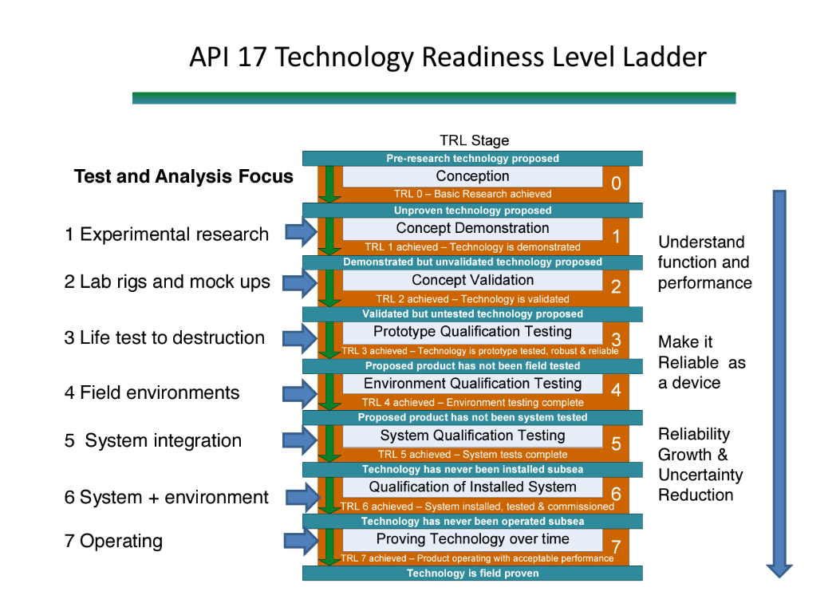
Figure 2: Technology Readiness Level according to API RP 17N
As a general guide, if the design and fabrication of the proposed FOWF is not being verified by an Independent Verification Body (IVB) e.g. via Class or Project certification, insurers will expect all components and systems to have reached TRL 7 according to an accepted system such as API RP 17N or the ORE Catapult’s TRL, in order to be viewed as ‘field proven’. It is anticipated that the Original Equipment Manufacturer (OEM) of each component or system will confirm the TRL level achieved by the specific model or variant, and the road map to achieving TRL 7 if not yet achieved.
The number of trouble-free operating hours in the field at full scale should be reported by the insured but is expected to be at least 8,000 hours including the winter period.
ORE Catapult UK proposes the following TRL definitions for floating offshore wind
TRL 1: Basic principles and concepts are being explored.
TRL 2: Technology is in the laboratory or experimental stage.
TRL 3: Proof of concept has been demonstrated.
TRL 4: Technology has been validated in a laboratory environment.
TRL 5: Prototype development and testing have occurred.
TRL 6: Prototype testing in a relevant environment (e.g., scaled model or controlled conditions).
TRL 7: Technology demonstrated in an operational environment.
TRL 8: Full-scale system tested and proven in an operational setting.
TRL 9: Technology is fully mature and deployed for commercial use
The party who defines the TRL of each component and subsystem shall preferably be an IVB or qualified third party, but if assessed by the insured they shall make clear reference to the TRL system being applied.

- Certification and Classification

  - Certification and classification overview

Certification or classification is the process of verifying the conformity of a product, system or service with the requirements and characteristics outlined in a technical standard, specification or regulation. Throughout this document, the organisation carrying out the certification or classification is referred to as the Independent Verification Body (IVB) and ‘project certification’ is outlined in parallel to classification.

The decision whether or not to pursue classification or project certification (or both) of a proposed FOWF lies with the project sponsor, however a number of wider requirements should be borne in mind. These are outlined below:

3.1.1 Statutory requirements
National Legislation
Some countries require project certification of offshore wind projects as a legal requirement. In other countries where it is not a legal requirement, either partial or full project certification can be achieved.
Flag State
With respect to insurance, flag state requirements address whether a FOWT is legal with respect to its location and status in whichever jurisdiction it is located. Please see section 6.3 for more detailed guidance on how flag state may provide assurance to both insureds and insurers.

3.1.2 Project requirements
Assets and components
The main components of a typical FOWF are presented in Figure 3 below.
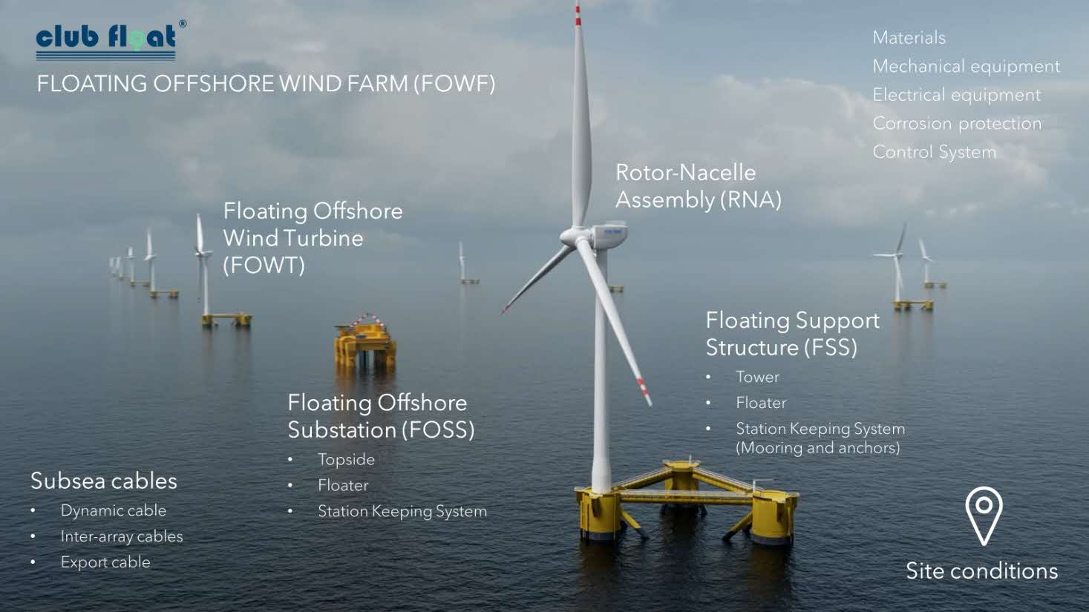
Figure 3: Typical components of a Floating Offshore Wind Farm (image courtesy of Niord/DNV)
Project phases
Independent third-party verification works are typically aligned with the project’s design, engineering, construction (or ‘execution’) and operational (or ‘in-service’) phases. By doing so, the conclusions and learnings from each phase can be implemented in the project without delay. At the end of each certification phase, which will follow the end of a project phase, the IVB will issue a deliverable. Running certification/classification activities parallel to the project activities allow for reducing uncertainties and minimizing risks. The typical project phases of a FOWF are shown in Figure 4 below.
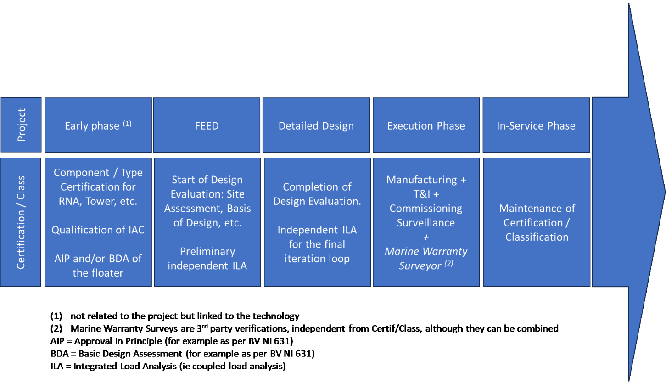
Figure 4: Timeline of typical project phases and corresponding certification and classification activities
3.1.3 Third-party project assurance
This section provides a number of considerations when choosing between certification (incorporating type certification and project certification) or classification.

Classification

According to the International Association of Classification Societies (IACS), the purpose of a classification society is to provide classification and statutory services and assistance to the maritime industry and regulatory bodies as regards maritime safety and pollution prevention, based on the accumulation of maritime knowledge and technology. The objective of the FOWT’s classification is to verify the structural strength and integrity of essential parts of its floater (hull) and appendages, the reliability and function of the power generation components within the rotor-nacelle assembly (RNA) and any other features and auxiliary systems which have been built into the FOWT in order to maintain essential services on board. Classification Societies aim to achieve this objective through the development and application of their own Rules and by verifying compliance with international and/or national statutory regulations on behalf of flag administrations.

Certification

According to ISO/IEC 17065, certification is ‘the provision by an independent body of written assurance (a certificate) that the product, service or system in question meets specific requirements’.

Some product, process or service certification schemes may include initial testing or inspection and assessment of its suppliers' quality management systems, followed by surveillance that takes into account the quality management system and the testing or inspection of samples from the production and the open market. Other schemes rely on initial testing and surveillance testing, while others comprise of type testing only.

Classification and certification in Floating Offshore Wind

Classification and certification are both important processes in verifying the safety, integrity, and compliance of offshore structures. Both schemes can be combined in order to provide third-party assurance of FOWFs. In its application to floating wind, classification is building on experience from vessels and floating O&G assets, while certification is building on experience from wind power (onshore and fixed-bottom offshore). Both certification and classification requires the IVB to assess the conformity of a product, system or service with the requirements and characteristics outlined in a technical standard, specification, and/or regulation. These standards or specifications are published by recognized international bodies (including classification societies, certification bodies, and normalization technical committees) and serve to provide assurance that a product, system or service is safe and fit for purpose.

Safety is proved through evidence that all assets of a FOWF (the FOWTs, substations if present, and cables) are designed according to a target safety level. Safety level refers to the degree of safety and reliability that an asset is designed to achieve. Both certification and classification processes aim to verify that the FOWF as a whole meets certain safety levels, although the specific criteria and requirements may vary. In certification, safety levels are typically defined based on regulatory requirements, industry standards, and project specifications. Safety levels in certification may include requirements related to structural integrity, safety systems, environmental impact mitigation, and operational procedures. certification bodies assess the design, construction, installation, and operation of a FOWF to verify that all meet the specified safety standards and criteria. The aim of certification is to provide assurance that the asset is designed and operated in a manner that minimizes risks to personnel, the environment, and assets.

Classification societies also play a role in defining safety levels through their rules, guidelines, and classification standards. Class societies establish technical standards for the design, construction, and maintenance of vessels and offshore structures to verify they meet specified safety and quality levels. Safety levels in classification encompass structural integrity, stability, reliability, and performance criteria set by the Class society. In addition, classification involves periodic surveys and inspections to verify that the relevant structures, machinery, equipment and systems continue to meet the required safety levels throughout its operational life. Periodic surveillance by an IVB during the operational phase is optional in project certification rather than mandatory.

  - Assurance options for Floating Offshore Wind

The below table provides an overview of the three approaches to assurance that are applicable to a FOWF.

Approach: | Project certification | Project certification | Project certification & Classification
According to: | IECRE-OD-502 | IVB-specific certification scheme | “Integrated”
IVB requirement | Must be accepted as an IECRE certification body | ISO/IEC 17065 accredited certification body by an IAF accreditation body | Must be IACS member and accredited certification body according to IEC/ISO 17065
Reference | certification Bodies (RECBs) | IECRE | Accreditation Bodies - IAF  DNV accreditation  BV accreditation | IACS members

To understand certification and classification processes, it is important to understand and distinguish the hierarchy in the documentation and consider that depending on the scheme, different terms might be used for the same category of documents. This hierarchy is shown in Figure 5 below.

Figure 5: Hierarchy of documentation for certification and classification processes

    - IECRE

The IEC System for certification to Standards Relating to Equipment for Use in Renewable Energy Applications (IECRE) aims to facilitate international trade in equipment and services for use in the renewable energy sectors while maintaining the required level of safety and performance.
IECRE achieves this goal via the following:
- operates a single, global certification system
- aims for acceptance by national/local authorities or other bodies requiring and benefiting from certification
- makes use of high-quality international standards and allows for continuous improvement
To be effective and avoid duplicated efforts of what information must be given, when and to whom, IECRE includes a mechanism to resolve disagreements between stakeholders in terms of the content and its correct application.
IECRE offers a harmonized application around the globe, which ensures a uniform:
- implementation and mutual recognition between certification bodies and test labs
- implementation and delivery of information by suppliers, sub-suppliers, end users, and others providing documentation for certification
- implementation and clear understanding of all suppliers, sub-suppliers, end users and other applicants for the elements and modules as well as reports, statements and certificates of the certification processes
For the wind energy sector, IECRE maintains the following relevant document types:
- Rules and Operational Documents (OD)
IECRE-OD-501
IECRE-OD-502

- Standards
IEC 61400 series

- Technical specification and informative appendices (TS, Appendix)⁸
IEC TS 61400

The IECRE OD-502 project certification process is shown in Figure 6 below.
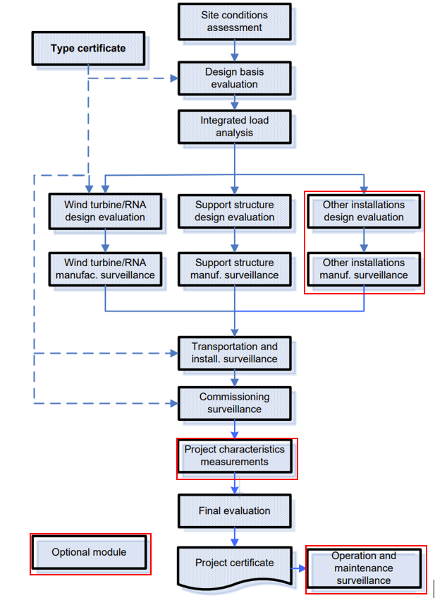
Figure 6: Overview of mandatory and optional modules (highlighted in red) under IECRE OD-502
It is noted that IVBs with their own project certification schemes have a project certification process that consists of modules similar to those in IECRE OD-502. Further information can be found on their websites.
The type certificate for the WTG must be compliant with IECRE OD-501 or equivalent such as DNV-SE-0441. An overview of the type certification process for wind is provided in Figure 7 below.
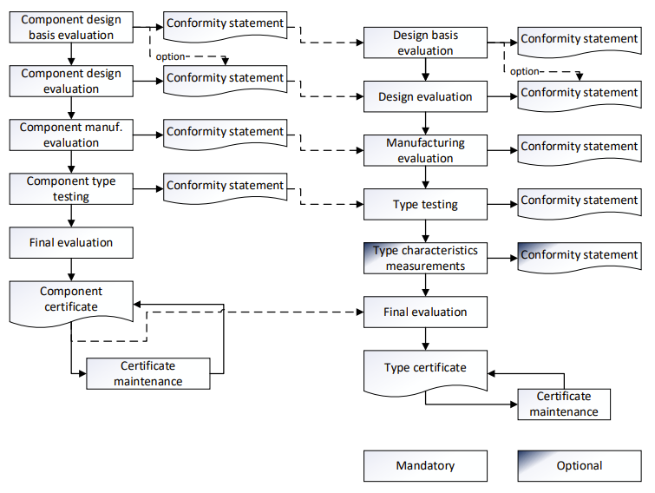
Figure 7: Overview of the type certification process according to IECRE-OD-501
It is noted that IVBs with their own type certification schemes have a type certification process that consists of modules similar to those in IECRE OD-501. Further information can be found on their websites.
    - Important distinctions between approaches

When considering which assurance approach to take, the project sponsor should be aware of areas of incompatibility between classification and project certification that stem from the scheme chosen, as well as differing accreditation requirements of the IVB under each.

Classification approach

Some Class Societies have developed dedicated Class rules for FOW installations, with a focus on the floating sub-structure and mooring. However, IECRE OD-502 does not allow for direct integration of these Class certificates with its project certification methodology.
For that reason, some IVBs have developed approved methodologies for carrying out this integration, as explained further below.

An insured could obtain classification for the floater and mooring system in addition to obtaining project certification for the complete FOWF, but this would require a gap analysis between technical standards to ensure that the technical requirements are compatible and avoid future non-conformities that would put the project certificate at risk.

Project certification approach

If an insured chooses to certify the floater and mooring system and obtains the WTG type certification according to IECRE OD-501, DNV-SE-0441, or equivalent, they could then proceed with the project certification according to IECRE OD-502, DNV-SE-0190 combined with DNV-SE-0422 or similar. As outlined below, the Class certificate may be integrated into a project certificate (which covers the above) via an extra step in the assurance process by a suitable IVB. It is noted that in project certification, the certified RNA is evaluated with respect to the specific project and site-specific conditions in project certification. Verification of site-conditions is not covered by classification, while certification of site-conditions is a key first step in certification.

  - Integrated certification and Classification

As noted above, Class is not recognized by IECRE, but the IECRE WTG Type certification (according to IECRE OD-501 or equivalent) can be recognized by Class.

Options for the integration of the different aspects of Class and project certification as a cohesive whole are presented below by DNV, BV and ABS.

    - Integration of certification and Classification (DNV)

DNV has developed a harmonized assurance solution that combines project certification and classification. It combines experience from project certification of offshore wind farms with the maritime execution model.

This solution is based on these three service documents:
- DNV-SE-0190: Project certification of wind power plants
- DNV-SE-0422: certification of floating wind turbines
- DNV-RU-OU-0512: Floating wind installations
It should be noted that project certification in accordance with DNV-SE-0190 & DNV-SE-0422 or IECRE OD-502 is also available. The choice of assurance approach - whether certification alone or certification combined with classification - will depend on the specific requirements set by the project stakeholders.
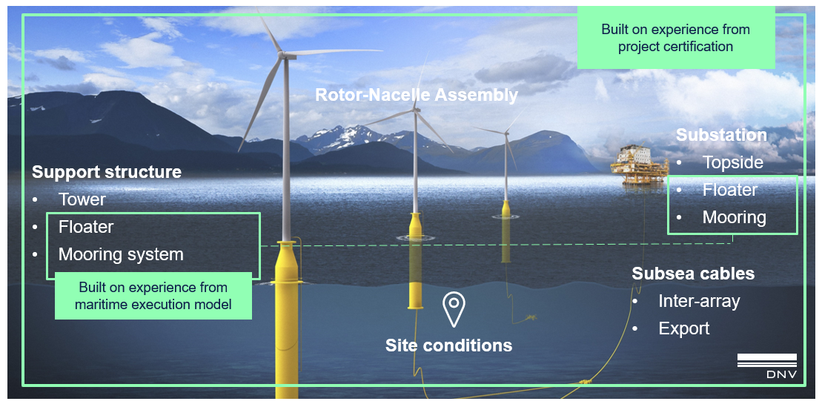
Figure 8. DNV assurance for Floating Wind Farms and certification phases (optional phases in light blue)

Project certification of the wind farm, according to DNV-SE-0190, covers all phases of the lifecycle of wind power plants (onshore, offshore and floating): from concept to in-service. Further phases such as repowering, lifetime extension or decommissioning are also included as optional. The following assets are covered: wind turbine including RNA and (floating or fixed) support structure, (floating or fixed) substation, inter-array and export cables and control station.
For floating wind turbines and dynamic power cables, DNV-SE-0422 supplements DNV-SE-0190. The classification of the floating support structure, i.e. the floater and station-keeping system, is conducted according to DNV-RU-OU-0512 which provides dedicated Class notations for the relevant items (e.g. WIND or POSMOOR).
The Rotor and Nacelle Assembly (RNA) is evaluated as part of the project certification, documented either by a type certificate or through completion of the mandatory phases of type certification, in accordance with DNV-SE-0441 or IECRE OD-501.
For Marine Warranty Services, DNV-ST-N001 serves as the technical basis, creating significant synergies with the transport and installation certification.
Special attention should be given to interfaces. Interface management is crucial, as floating wind projects involve multiple project and certification phases and independent stakeholders, such as developers, owners, and manufacturers collaborating for the first time. DNV’s third-party assurance (whether certification alone or combined with classification) is a recognized tool for managing and mitigating risks, with a key focus on consistent design standards that ensure a safety level that is deemed acceptable for the floating wind industry.

    - Integration of certification and Classification (BV)

Classification provided by BV is based on BV Class Rules and the available IECRE OD 501 Type Certificate via an integration approach, which is as follows:
- IACs are classed using BV Class Rules. At time of writing, BV have recently developed a Class notation for IACs and are about to issue a standard specifically for dynamic cables. It is noted that Floating Offshore Sub Stations are not yet covered by Class

- The WTG Type Certificate is integrated into the classification according to BV Rule Note NI 572. It is noted that BV have developed a Class Notation for WTGs but the Class would rely on IECRE type certification

The BV classification scheme for floating wind is shown in Figure 9 below.
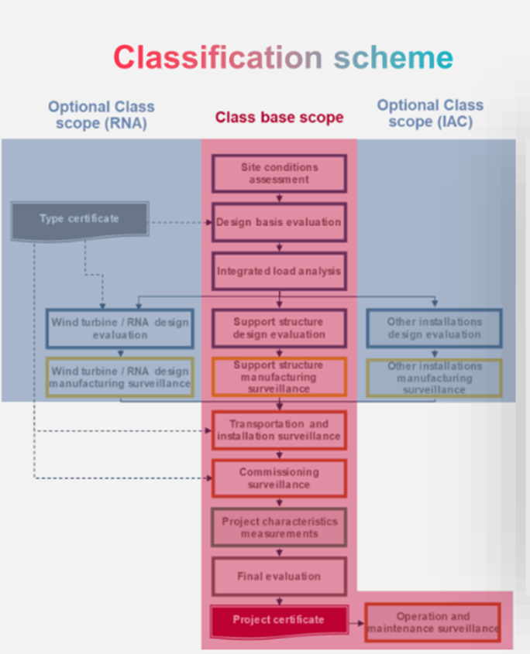
Figure 9: BV Classification approach derived from BV Project Certification Scheme, BV NI 631

    - Integration of certification and Classification (ABS)
At ABS, the integration of certification in the classification process of fixed-bottom or floating wind turbines is based on the published ABS Guide documents, and is as follows:
- Classification of the fixed-bottom WTG substructure and foundations and the floating substructure, station keeping system and applicable marine systems is based on the “ABS Guide for Building and Classing Bottom-Founded Offshore Wind Turbines”, and the “ABS Guide for Building and Classing Floating Offshore Wind Turbines” respectively. These include all project phases from design, through to construction, installation, commissioning, and surveys during operation.
- Where the RNA and the tower are not included in the classification, they are required to be type certified in accordance with IECRE OD-501. This is reviewed by ABS to verify they are consistent with the design information, criteria, and limitations of the Classification.
- As an option the RNA and the tower can be included within the classification scope and assigned a Class notation, based on site-specific assessment to verify that loads and deflections calculated under the site-specific conditions do not exceed those calculated for the RNA and the tower approved by the ABS Type Approval.
- Additionally, ABS can Class fixed and floating Offshore Substations and Electrical Service Platforms, based on “ABS Requirements for Offshore Substations and Electrical Service Platforms”.

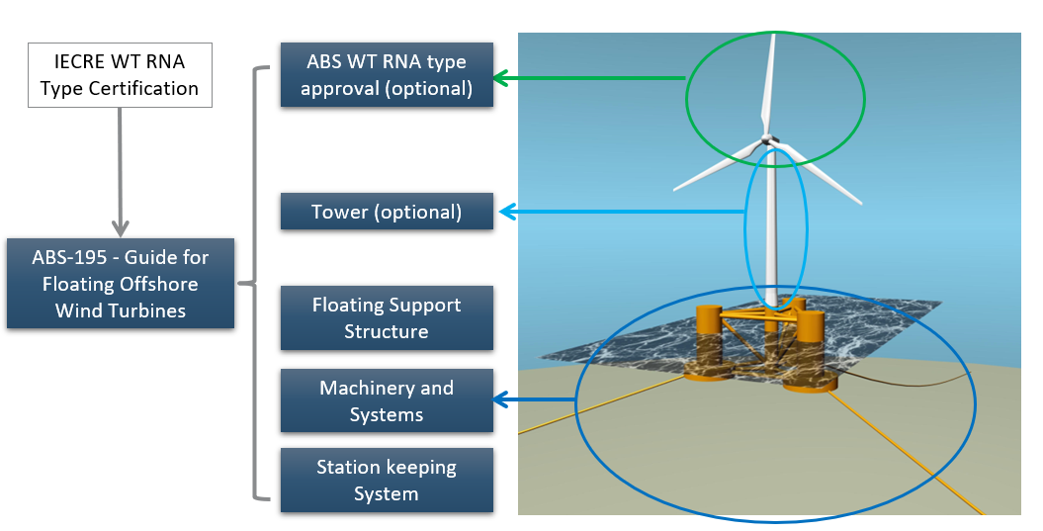
Figure 10: Overview of the ABS Classification scheme for FOWTs

It is noted that other IVBs may have their own approach on certification and classification of floating offshore wind. Please visit their own websites for further information.

    - Impact on insurer’s risk review process

Providing the above considerations are taken into account to ensure a holistic approach, both classification and project certification provide increased comfort to insurers that a proposed FOWF has been independently verified by an expert third party. However, before selecting which approach to take, a gap analysis should be performed due to the constant evolution of technical standards, especially classification society rules and the rapid changes in the industry. It is recommended that insureds explicitly specify the requirements in terms of independent analysis to be performed by the IVB to enable the insurer to understand the breadth and depth of the verification undertaken.

  - Summary – certification and Classification

Concern | Recommendation
Risk of gaps and weaknesses in the overall project certification or classification scheme applied | All assets and all phases should be addressed in a consistent manner.  Insured should provide the rationale for their choice of approach.  Insured should provide an overview of where the gaps exist and how they have been addressed via additional engineering input.
“Once and done” approach. | If Classed, should follow the marine maritime model of being re-classed throughout the lifetime of the asset.  If certified, in-service certification should be followed throughout the lifetime of the asset.
Inspection frequency during fabrication  Neither Class Rules or IECRE OD502 explicitly define minimum inspection frequency (i.e. sampling rates) required during fabrication. | By default, a 20% inspection frequency on fabricated components should be required (as a minimum). For components for which Type certification is required, the inspection frequency could be lowered to 10%.  DNV specifies the extent of fabrication follow up in DNV-OS-C401 for structural fabrication surveys, DNV-OS-E301 for mooring systems and in DNV-SE-0441 for the wind turbine.  Inspection frequency should be defined at the project outset in the Request For Proposal for project certification / classification services. This can be used as a basis for a fair IVB selection process.
Material certification during fabrication  This certification activity consists of gathering material certificates to ensure they are consistent with the Employer’s Requirements issued to the contractors.  Most of the time, self-certification by the Contractors is sufficient.  Even though Class Rules for floating wind on this topic still need to be determined, the Class philosophy as applied to Vessels and O&G units, is to certify the material used for most of the components that are Classed. | It is advised to list all critical components for which project certification is not sufficient on its own and will require the approval of a specialist materials IVB.  For example, the following components, due to their importance, may be considered:  Flanges between tower and transition piece.  Critical structures of the floater.  Mooring connectors.  Appurtenances welded to the floater.
Load-out, Transportation & Installation  During these phases the IVB and the Marine Warranty Surveyor (MWS) are required to give approval. The MWS is required to follow the appropriate MWS Scope of Work and ultimately issue a Certificate of Approval if satisfied that all risk are mitigated. Whilst having similar objectives, the MWS must perform a discrete function independent of the IVB otherwise issues of conflict of interest may arise  If poorly defined, the scopes of work of the IVB and MWS may become muddled or overlap one another, leading to gaps in coverage. | Early in the project the insured should create an overview of the scope of responsibilities of both the Certifier and MWS which clearly delineates between the two. This should be shared with the Insurers.
Commissioning  Verifications by the IVB are limited to:  - Clearance of the ‘punch list’ items (i.e. open comments from previous phases)  - Witnessing of key functional and safety tests  - WTG OEM commissioning certificates | It is recommended that a detailed list of commissioning tests, to be witnessed, are issued by a 3rd Party after discussions between Operators, Insurers and certification bodies.
In-service certification/Classification  Project certification has the option to maintain certification during the operational phase of a project.  The base case, for classification, includes Operations in the classification scope, typically, through inspections. This is mandatory in order to keep the Class certificate throughout the lifetime of the asset. | It is advised to perform regular inspections on the units, especially on the dynamic components (moorings, floater, IAC’s, etc) for the following reasons:  - Multiple similar assets.  - Units operated in a harsh environment which will be subject to corrosion and fatigue.  Therefore, it is strongly advised to maintain the certification and / or classification of the units when in Operation.
Potential for having different IVBs for each element of the work and therefore a risk of an ‘interface gap’ between IVBs occurring. | certification scope should not be fragmented; as a minimum the scope for the entire design phase should be handled by a single IVB, and entire execution (fabrication / Transportation & Installation / Commissioning) phase too.
Potential for having a project design certification only, i.e. Execution phase (fabrication / Transportation & Installation / Commissioning) is not evaluated | Project certification (and not solely project design certification) should be pursued

Design of Mooring System
4.1 Overview
The principal function of the permanent mooring system is to provide the station keeping capability for the FOWT. The mooring system of a FOWT may be discrete to each FOWT or affix multiple FOWTs to the seabed. The variety of mooring systems proposed currently may include a combination of different anchoring systems, chain section, synthetic fibre rope and connection types. Such mooring systems have had years of operational hours but only for a few floating wind turbine concepts (with semi-sub and spar floaters).. As such, directly relevant operational and loss data for FOWT mooring systems are scarce which presents a challenge for insurers when evaluating the associated risk of failure.
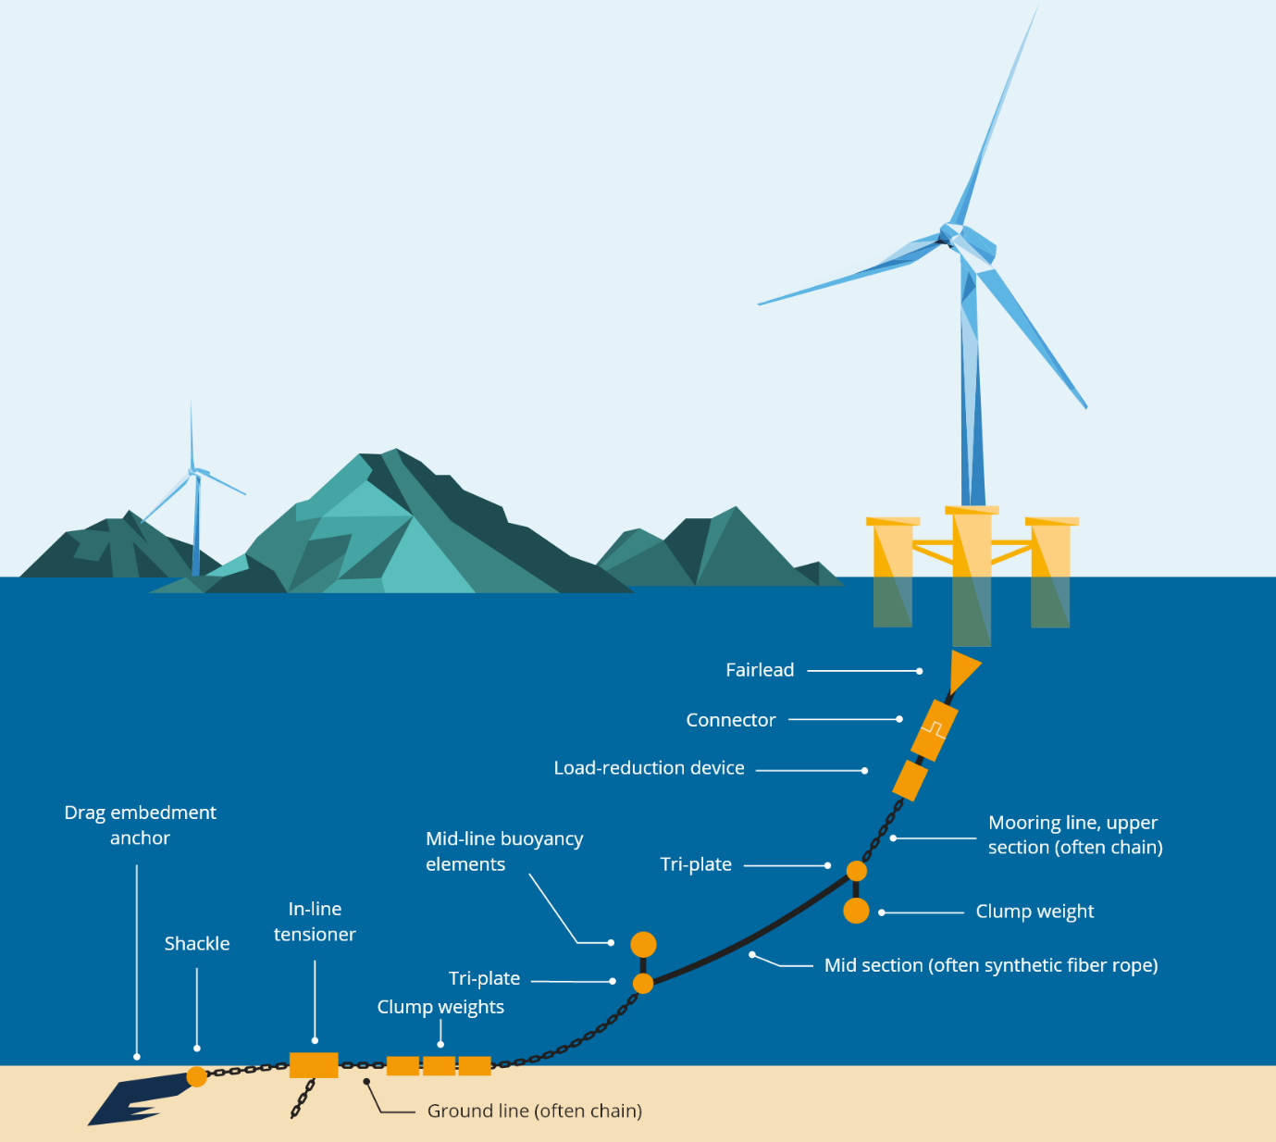
Figure 11: Overview of a typical mooring system for a floating wind turbine

4.2 Failure modes
Whilst the JNRC are not aware of any failures of FOWT mooring systems which resulted in significant WTG downtime (to date), many early projects over-designed the mooring systems to guard against failure. The drive to reduce the levelized cost of energy for floating wind implies this will not remain the case. This, coupled with a global drive to increase the size of WTGs and a global shortage of the largest chains required to moor such WTGs means insurers cannot avail of previous loss data from either FOWTs or oil and gas when considering pricing and coverage for new floating projects. This absence of experience places even more reliance on the accuracy of the models used to predict the static and dynamic loads, wear, corrosion and fatigue rates of the mooring system to ensure the design and materials selected will not suffer potentially catastrophic failures.
Experience from upstream oil and gas shows that failures can be caused by some of the following:
- Design error
- Material selection error
- Wear (friction on adjacent/interface components)
- Corrosion (related to/in combination with tensile stress and hydrogen embrittlement).
- Abrasion and degradation
- Corrosion of chain/wire
- Fatigue damage due to:
  - crack initiation from repetitive axial and out-of-plane bending stresses (an issue for mooring chains)
  - hydrogen-induced cracking/hydrogen embrittlement,
  - dynamic response to cyclic loading
- Fabrication defect (impurities in material, poor coating)
- Overloading (high tensile or bending loading)
- Installation or operational error (including human error)

Some of these failure modes cannot be accurately predicted at the design stage,, such as fabrication defects or human error during Transport and Installation (T&I) work, reinforcing the requirement for practical mitigation measures. Wear and corrosion can act synergistically and experience from upstream oil and gas shows that models used to predict wear and corrosion require further validation to improve predictive accuracy. This inability to predict certain failure modes emphasizes the need to ensure that mooring system designs for FOWTs include adequate safety factors and/or redundancy.
Options for reducing the risk of mooring line failure include:
- Increasing the mooring strength capacity - increased strength safety factors
- Increasing chain diameter, increase in number of mooring lines
- Component selection (proven reliability & compatibility)
- Fabrication inspection, traceability, loading history of all mooring components from fabrication to commissioning (and after during operation)
- Enhanced inspection & maintenance requirements, including the use of digital twins to inform preventative rather than reactive maintenance
- Condition monitoring

4.3 Design concepts
Mooring line design concepts vary between different conceptual floater designs (including semi-submersible, spar, tension leg platform, or barge floaters). Design concepts depend on location-specific soil and environmental conditions. These concepts principally include catenary, semi-taut, taut and tendon lines, in order of increasing initial tensioning of the system.
The semi-submersible, spar, and barge floater types are moored to the seabed via pure catenary or semi-taut mooring lines made of chains, steel wire ropes, or synthetic fibre ropes (nylon, HMPE, polyester), or a combination of these, connected to the anchoring system. The TLP is vertically moored with taught tendons which are connected to the anchoring system. Polyester has long been used for long-term mooring systems by the oil and gas industry which provides a useful operational track record, albeit one not directly applicable to floating wind given the very different design requirements. The use of nylon and HMPE is far less developed by either industry.
The combination of mooring materials, as well as their relative lengths, configurations and tensioning and their corresponding anchoring systems are project specific and so mainly depend on soil conditions, environmental loads from wind, waves and current, and the operational behaviour of the WTG. The mooring system must be designed to ease installation, hook-up, and connection-disconnection for major repair, to avoid time consuming and costly re-engineering should a tow-to-port be required. Components (jewellery and connections) may include fairleads, connectors, load-reduction devices, clump weights, buoyancy elements, tensioners, swivels, shackles, and anchors.
All mooring system components must be designed for all phases of the project and their corresponding loading scenarios (fatigue, ultimate and accidental limit states) encompassing their design life (transportation, load-out, installation, operation and decommissioning phases). Shared anchoring and mooring systems between multiple FOWTs should be designed in accordance with appropriate design rules, although these rules require further development and such designs are therefore likely to be viewed as less proven than single FOWT mooring systems by insurers. Concepts involving shared anchoring systems should clearly outline how the design mitigates the risk of multiple FOWTs becoming unstable should one anchoring system fail.
4.4 Anchors
Anchor types mainly depend on geotechnics and mooring line design and adequate tensioning. Anchor types are summarised below along with their key characteristics.

Type of anchoring system | Comments
Suction anchors | Some experience from fixed-bottom offshore wind farms (OWF). Very sensitive to soil conditions
Driven piles | Traditional, well proven design but require heavy pile driving hammers and the most complex installation spread.
Drag embedment | Cheap to install but sensitive to soil conditions and can drag under load. Not suitable for use as shared anchors, as their nominal holding capacity is very limited to the installed direction of pull.
Gravity anchor | Usually only used for temporary holding conditions and/or in sheltered environments
Torpedo anchor | Not widely used, soil sensitive and anchoring. Capacity difficult to predict
Other drivers for anchor choice include transportation and installation costs and the associated cost of repair in the event of a failure. A clear justification for the choice of anchor, supported by detailed geotechnical reports and loads analysis must be provided for review.

4.5 Redundancy
The redundancy of the mooring system should be clearly defined, since failure of a mooring line may result in one or more of the following:
- Loss of structural integrity and floating stability, including the design envelope being exceeded;
- Loss of or deviation from position;
- Inability to export power due to cable damage. Depending on the IAC system design, this could result in the entire FOWF being unable to export power.
Therefore, the insured should provide a risk assessment which explains the relationship between different types of mooring line failures and the impact on:
- The affected FOWT’s structural integrity and floating stability
- The affected FOWT’s ability to export power, referring to the load limits of its cable
- Other FOWTs’ ability to export power
- Other FOWTs’ structural stability, in the case where mooring lines are connected to multiple FOWTs.
This risk assessment should refer directly to the proposed mooring integrity management system, including the types of mooring line failure that can be repaired in-situ, which will require replacement, and make reference to what spares will be held onshore by the insured.
DNV’s definition of mooring redundancy within DNV-ST-0119 stipulates that in the event of a single line failure the remaining parts of the system must meet the Accident Load State (ALS) criterion survival of at least one-year return-period loads. The redundancy criterion only considers that the floating structures should “not collide with other nearby structures and not be free-drifting due to loss of one mooring line” and does not state whether the cable(s) must remain undamaged too. However, it goes on to state that “the consequences of damaging the cable should be considered by the designer/operator in terms what is acceptable and if it will be possible to repair/replace the cable (e.g. related to the bounds of the insurance coverage)”.The insured should, therefore, clearly explain their assumptions around power cable integrity in the event of mooring line(s) failure including any emergency disconnect systems that are designed to allow the cable to safely disconnect if put under excess tension due to the FOWT moving significantly off-station.
See section 8 (cables) for further detail on cable emergency disconnect systems

4.6 Mooring Integrity Management
It is an industry consensus that a Mooring Integrity Management (MIM) plan consisting of the condition monitoring of key parameters of the mooring lines (mooring line tension, curvature/bending, motion, corrosion, etc...), combined with regular and planned inspections, is crucial to prevent and decrease mooring line failure rates, and increase reliability and availability.
Monitoring solutions for mooring systems can be summarised as:
- Risk-Based Inspections (RBI) such as visual inspection of connectors
- Underwater inspection using remote operated vehicles (ROVs) or autonomous underwater vehicle (AUVs), and surface inspections using aerial drones
- Condition monitoring systems (CMS) based on sensors fitted to the FOWT and MRU (motion reference unit) data to infer remaining fatigue life from motions/position and detect excessive offsets such as deviations from station. Data from the CMS may be used in a ‘digital twin’ environment in which a portrait of the actual loads experienced can be compared to the design loads, to inform preventative maintenance or inspections.
To assist with Mooring Integrity Management the JNRC has developed a practical method for auditing mooring systems. This is called FUMA (Floating Unit Mooring Assessment) and is described in the document Doc. No.: JR 2024/044 at the following link:
https://www.lmalloyds.com/LMA/Underwriting/Marine/JRC/scope_jrc.aspx
Although originally written for the oil and gas industry, this document has recently (July 2024) been updated to cover FOWTs.
FUMA is written around Generic Scopes of Work (GSoW) using four levels of assessment, each progressively more onerous. These GSoW can either be used as individual Scopes of Work in their own right or sequentially, as required. They are defined as follows:
GSoW 1 | Level 1 | Remote Technical Survey: Desk-Top Evaluation, Correspondence and Technical Review
GSoW 2 | Level 2 | Site Attendance:  2a. Onshore, or  2b. Offshore
GSoW 3 | Level 3 | Engineering Assessment and Visual Inspection of Moorings
GSoW 4 | Level 4 | Engineering Assessment and Detailed Physical Inspection of Moorings

The FUMA document referenced above provides the full Scope of Work requirements together with guidance notes, a Code of Practice and information on the Initial Screening Process.
In addition, communication with marine stakeholders to avoid vessel collisions with FOWTs or trawling of cables is highly recommended.
The insured should provide an overview of the frequency of RBI and underwater inspections, explaining the rationale for smart sampling if a subset of moorings is to be inspected each year (for example, based on CMS data). CMS require an initial period to collect baseline data, so insureds should explain how the CMS will detect anomalies early in the operational lifetime. Preventative repairs based on CMS data can help with scheduling for weather windows and reduce vessel costs and may reduce the risk of large business interruption costs associated with a severe mooring system failure.
Inspections should cover known critical areas including:
- Top chains (fairleads, stoppers)
- Wire rope terminations
- Connectors (shackles, tri-plates)
- Seabed touchdown area
The Mooring Integrity Management plan should include a monitoring plan, an inspection and measurement plan to allow preventative maintenance, and a failure response plan. A spare part strategy should also be presented. Good practice would also be the maintenance of a mooring computer model that can be used to assess damage to any part of the mooring system.

4.7 Summary – Design of Mooring System

Concern | Recommendation
Design of mooring system is not fit for purpose | All components (mooring lines, anchors, ancillaries) should obtain third party design certification and be included in the scope of project certification.
Uncertainty over likely impact of a single mooring line failure | Insured should explain the consequence of a mooring line failure including residual stability, performance, and impact on power cable(s).
Uncertainty over likely impact of multiple mooring line failures | Insured should explain the consequence of multiple mooring lines failure including residual stability, performance, and impact on power cable.
Will ongoing monitoring and inspection programmes able to prevent severe failures of the mooring system? | All CMS, ROV/AUV and other inspection regimes should be clearly explained, along with associated data collection and management systems It should also be clearly stated whether the mooring system is subject to continued classification in the operational phase.
Redundancy | Insured should clarify their definition of redundancy.

Design of Cable System
5.1 Overview
Losses caused by failure of Inter Array Cables (IACs) and export cables continue to dominate claims associated with fixed-bottom offshore wind. Whilst some failure mechanisms associated with those claims may not be directly applicable to floating wind, other new failure mechanisms may arise, making cables a key topic of focus for insurers. Generally, cables should be sourced from reputable manufacturers and with competent personnel engaged by the Insured to engage with the manufacturer and take sound and reasonable decisions as progress is made in manufacture, particularly when Non Conformance Reports (NCRs) are issued, or any changes are made to the pre-approved design or fabrication process.
Unlike fixed-bottom offshore WTGs, FOWTs require some or all of their power cables to be dynamic – that is, designed to permit movement but withstand loads from waves, currents, and the motion of the floater itself without suffering damage. Whilst dynamic cables have been used in the upstream oil and gas industry for decades to supply power to rigs and FPSOs, they have generally been for far lower voltages and in significantly deeper water depths than would be required for a FOWF. As a preference, the design, fabrication, installation and commissioning of all cable systems including all accessories should be included in the project certification scope. It is however recognised that, as of writing (September 2024) no standards exist which are suitable for the type and rating of cables required by many proposed FOWFs.
The cable system connecting a FOWT to either another FOWT, an offshore substation or to the onshore substation is here taken to include:
- Cables, containing power cores (conductors), fibre optic cores, associated screen, insulation, sheath and armour components;
- Cable connectors, whether dry or wet mate in nature. These include terminations and joints;
- Ancillaries, including buoyancy modules, ballast modules, bend stiffeners, bend restrictors and cable protection systems (CPS) designed to stop damage to the cable from friction and abrasion with the seabed or floater itself. Tethers and additional systems designed to hold the cables safely prior to termination at the FOWT may also be present.
By awarding the contract for cable packages to one EPCI contractor where the functional design of the entire system is in the scope, insureds will benefit from reducing interface risk and avoiding gaps between separate packages. A multi-contract approach will require additional effort to ensure nothing falls through these gaps during the design, fabrication or installation phase.

5.2 Cable types and failure modes
The dynamic cables used for IACs are typically of ‘wet type’ design. Traditional ‘dry type’ static cables use an extruded metal sheath (typically lead) over the insulation to act as a water barrier for the cable, however such designs are not suitable for dynamic cables as the lead lacks fatigue resistance. Wet or semi-dry type cables use materials other than lead to act as a partial water barrier and are lighter, lower volume and cheaper than dry type cables principally due to the absence of lead. The static cables likely to be used for some or all of the export cable route are expected to be dry type, an application used in the majority of fixed OWFs in operation today at voltages of 300kV and above.
Moisture, temperature and electrical stress in the insulation system can all result in premature ageing and failure of the cable. ‘Water treeing’ is caused by water penetrating the insulation when under load, causing ‘trees’ to grow over time until they result in a breakdown of the insulation system. Electrical ‘treeing’ is also a risk, but a key focus of cable design should be to prevent water tree initiation through application of water barriers and/or enhanced insulation material such as water tree retardant cross linked polyethylene (XLPE). If non-lead waterproof barriers are used – which is a solution being proposed for wet type dynamic cables – insurers will require additional evidence that the design is fit for purpose, since it has a very limited track record at the voltages proposed for most current FOWFs. If the proposed cable has been tested to IEC 63026, CIGRE TB 623, 722 and 862, this will provide confidence to insurers that the design as it relates to dielectric strength of insulation when immersed in sea water is fit for purpose, since dynamic movements will not accelerate the water treeing growth rates unless the minimum bending radius (MBR) is compromised. Careful handling of cables is crucial to maintain the MBR whether the wind farm is fixed bottom or floating and if the MBR is exceeded on a dynamic cable this may cause accelerated water tree growth to occur.
The majority of IAC and export cables used in fixed-bottom OWFs incorporate fibre optic cores as well as power cores. By contrast, dynamic cable designs used to supply power to upstream installations often have the fibre optic cores contained in separate cables, which if applied to FOW would not allow condition monitoring systems (CMS) applied to the fibre optic cores, such as DAS, to monitor the health of the power cores. As such, this shall be an important point of clarification for insurers.

5.3 Design considerations
The IACs are likely to be a mixture of dynamic and static type design, whereas the export cable(s) running from the nearest FOWT to shore, or from the Offshore Sub Station (OSS) to shore, are likely to be of static design for most of their length.
Lazy wave or W wave
IAC’s connecting FOWTs in a farm to each other and into the OSS are assumed to follow one of two designs:
- Lazy wave, in which a portion of the cable (hog bend) is buoyant and cable ancillaries help maintain the appropriate cable shape in the water column until the touch down point is reached. The cable may be of dynamic design across its entire length, or switch to a static design where on the seabed or buried.
- W Wave, in which the whole IAC is dynamic and remains in the water column from connection to connection.
It is assumed that, whether a cable is dynamic or static, the cores are continuous and the difference (between the static and dynamic components) is in the outer sheath and armour. If an underwater interface is proposed at the junction of the dynamic and static cable in the form of an asymmetrical factory transition joint or an asymmetrical rigid joint that will be made during installation, the proposed joint should be included in the cables certification tests according to the relevant standard (see section 5.4).
All export cables are assumed to require seabed burial for at least part of their length, and may therefore feature a mixture of dynamic and static cables. The transition from dynamic to static cables presents a key interface risk, especially if a junction or joints are also incorporated. Given the number of failures from fixed-bottom caused by static cables moving too much due to a lack of stabilisation, insureds should provide evidence that Cable Protection Systems (CPS) and other ancillaries will be adequate to prevent damage, especially in the vicinity of the touch-down point. It is recognised that the deeper waters associated with FOWTs compared to fixed-bottom offshore WTGs have lower currents and negligible wave loads at touchdown, which should result in far less scour and abrasion of FOWT cables. However, the potential for cables to be damaged by movement around and against the floater itself is unique to FOWTs so additional protection may be required.

5.4 Standards and codes
The existing standards for the design of Oil and Gas umbilical cable systems under mechanical fatigue (ISO 13628-5 and DNV-RP-F401) provide a good basis for specifying MV and HV dynamic cables but they do not address all topics adequately. Standards for dynamic 132kV and wet-static 132kV cables need the most work and whilst some new designs have been qualified to CIGRE TB 722, there are no standards currently in place for wet type, dynamic cables of 30 kV and above. DNV RP F401 covers design and testing of dynamic cables up to 30 kV only. The main tests of importance to a cable are the crush test, tensile test and a type test. CIGRE have set up a working group to create a standard for the mechanical testing of dynamic cables which provides useful guidance (CIGRE TB 862 and 623). IEC 63026:2019 specifies test methods and requirements for cables and their accessories for fixed submarine installations but only up to 66 kV rated system voltages
(U_{m} = 72.5 kV). Furthermore, this standard does not apply to submarine cables for dynamic applications (i.e. for direct connection to a floating structure), for which modifications to the standard tests would be necessary.
Applicable codes and standards for FOW cable systems include:
- Subsea power cables for wind turbines (DNVGL-ST-0359)
- Recommendations for Additional Testing for Submarine Cables (CIGRE TB 722)
- Recommendations for Mechanical Testing of Submarine Cables for Dynamic Application (CIGRE TB 862)
- Electrical Power Cables in Subsea Applications (DNV-RP-F401)
- Subsea Umbilical’s (ISO 13628-5)
Ancillary components, such as buoyancy modules, are part of the whole cable system design and should be designed for the same loads and environmental conditions that the cable is designed for. Interfaces (point of fixation or contact) between the ancillary components and the cable itself should be investigated adequately in the design as they may represent spots with increased load concentration.
The current CIGRE standards do not stipulate the need for the cable qualification process to include ancillaries. This provides a number of blind spots in the application of said qualification process to the real-world integration of these various components and increases the risk of problems occurring as a result of either incompatibility or unexpected mechanical, electrical or heat stress which have not been modelled or tested prior to deployment. Overall, any physical discontinuity within or around the cable system including ancillary components, tether, interface fixation/hang-off at platform, connectors, or joints between dynamic and static sections, may represent locations of increased risk for the cable’s integrity.
Where gaps exist in the application of codes and standards to the cable system design proposed, the insured must explain how additional testing has been undertaken and the resulting Technology Readiness Level they believe has been achieved.
5.5 Cable connections
The cable connection at the floating platform level is currently an area where design standards remain obscure. The insured must clearly state whether the cables are dry mate, where they are terminated on the floater above the splash zone, or wet mate, where they are terminated underwater. It is noted that wet mate connections for cables above 33 kV have a very limited record of accomplishment and involve onerous and expensive testing procedures requirements.
Additionally it is for the insured and designers to consider an appropriate connection/disconnection system of the cable that will prevent cable breakage/failure during an accidental event (such as loss of a mooring line), to facilitate repair activities and tow-to-port Operations and Maintenance (O&M) operations. Where an “auto-disconnect” or “weak link” system is proposed which is designed to allow safe disconnection of the IAC or export cables in the event of the FOWT moving off-station (for example as a result of the failure of a mooring line), the scenario and cable load limits which the system is designed to accommodate must be clearly defined. The stated level of redundancy in the mooring system should be explained with reference to the capacity of the auto-disconnect system to enable insurers to understand under what scenarios power could be lost from one or more FOWTs.
Such systems are largely unproven and their Technology Readiness Level should be clearly stated to allow insurers to decide or consider what level of defect cover is appropriate.
5.6 Verification
Project certification of IAC cables is an optional module under IECRE OD-502, as well as comparable BV and DNV classification systems. Also, without the qualification of any new cable system designs, attempts to include cables in a project certification scheme are likely to be limited in their efficacy. The optional nature of certification, coupled with the lack of a specific comprehensive design standard for FOWF cables is also preventing cables from regularly being included in the certification scope.
If the cables, connectors and all ancillaries are to be verified without the input or guidance of an IVB then sufficient confirmation of the suitability of a design and its construction must be provided, for example to TRL 7. This assurance may involve examination of design analysis results, model testing or CFD (Computational Fluid Dynamics) analysis and 3rd Party assessment to examine the feasibility of the design for the stated conditions.
Insurers will also require information on fabrication quality assurance and quality control, such as:
- A reasonable level of NDT (Non-Destructive Testing)
- Dimensional checks
- Component suitability and quality
- Factory Acceptance Testing
Factory Acceptance Testing (FAT) would be expected to include the following as a minimum:
- Visual checks
- Conductor Resistance test
- Insulation Resistance test
- HVAC test
- DC test of over sheath
- Capacitance test
- Time Domain Reflectometry
- Optical Time Domain Reflectometry
Final as-built drawings must also be produced to ensure that all changes have been recorded and accepted and, above all, reasonable criteria (both design and environmental) are being used to ensure design adequacy. It may prove more onerous to demonstrate this than to have the cables initially designed and fabricated under the auspices of an IVB.

5.7 Installation
The JNRC has published a detailed scope of work and code of practice for Marine Warranty Surveyors working on offshore wind construction projects and this contains a scope specific to cable installation for FOWF. As well as ensuring that the aforementioned JNRC document serves as the basis for the cables package scope of the MWS employed on a particular risk, the insurer will also look for evidence that the installation procedure for IACs and export cables has:
- Been developed with input from the fabricators of the cables and all the ancillary components including connections, buoyancy units, cable protection systems to ensure no gaps exist in assumptions around how these components interface and connect
- Highlighted which vessels will be used to deploy dynamic cables, as well as the maximum working limits on wave and current associated with the safe deployment, wet storage and connection of cables to the FOWT
- Explained how the interface between dynamic and static sections of cables shall be installed and whether divers or remote operated vehicles are required
- Taken into account best practice for the safe handling of dynamic cables onboard the installation vessel, highlighting how handling requirements differ from the static cables being used
- Clearly shown how any wet storage of cables (that is, cables being left in the water or on the seabed prior to connection) will mitigate the risk of vessel collision, entanglement with mooring systems, and water ingress through temporary measures such as temporary buoyancy, marking, monitoring and capping of cable ends.
Tests carried out on the cables after load-out provide extra assurance to insureds and insurers alike that no damage has been done to the cables during transit or spooling/unspooling. These tests include the use of an Optical Time Domain Reflectometer (OTDR) to create a virtual “picture” of the fibre optic cables and find faults. Time Domain Reflectometers provides the same check on the power cores.
Experience to date has shown that having a representative from the cable OEM and the connector OEM on site during installation pays dividends in ensuring that the deployment and connection of all components is done in accordance with its intended design. The use of inexperienced contractors with no such input from designers is likely to result in more restrictive terms being offered by insurers, reflecting the large percentage of cable claims from fixed-bottom OWFs that have stemmed from errors during installation.
Cable installation and commissioning testing is discussed further in section 11.5

5.8 Condition Monitoring Systems
Monitoring of cable health plays a crucial role in the ability of the insured to carry out preventative inspection and maintenance, rather than waiting for a cable to fail. CMS options for cables may be split into two categories:

- CMS during cable Installation, including systems aimed at ensuring that cable limits such as minimum bend radius are not exceeded during handling or installation. OTDR is the most common CMS employed for this purpose and data should be made available for review by the MWS if requested.

- Operational CMS, including systems aimed at ensuring that cable temperature and physical load limits are not exceeded either as a result of cable defects, damage or other external forces such as an increase in the depth of burial due to mobile sea beds. Data from the CMS are collected and displayed via the FOWF’s SCADA system and may be used to justify unscheduled inspections or remedial works..

Types of operational CMS applicable to a FOWT and therefore of interest to insurers include:

- Distributed Temperature Sensing (DTS)
DTS provides continuous temperature monitoring of power cores, detecting hot spots, cold spots and thermal bottlenecks, delivering operational status, condition assessment and power circuit rating data;

- Distributed Acoustic Sensing (DAS)
DAS uses the fibre optic cores in a cable to ‘listen’ 24/7 to acoustic signatures, including signs that the cable or its CPS is under excessive stress.

The aim of including a cable CMS in all cases should be to support preventative maintenance rather than facilitating a “run to failure” approach to asset management which could result in unplanned outages and significant claims on the OAR policy. It is noted that relatively few systems exist to provide real time monitoring of the state of health of cable terminations whether on the FOWT or substation. Such systems have the advantage of being able to instigate an inspection on the WTG or OSS if safe termination temperatures are exceeded without the need for costly lifting of the cable for inspection. Clarity on all condition monitoring systems should be provided along with the spares held by the insured available should interventions be necessary.

5.7 Summary – Design of Cables
Concern | Recommendation
Clarity on interface between cable warranties and the insurance cover being sought | Scope of all warranties pertaining to the cable should be provided for review. Should also include a list of inclusions, exclusions e.g. costs for contractor vessels required to carry out a repair. This includes all accessories and ancillaries and must detail the defects notification period (DNP).
Lack of standards and testing guidelines for dynamic cables; cables an optional module under most classification systems | Third party verification of the overall cable design should be provided including all connections and ancillaries. If the cables, connections and all ancillaries are to be verified without the input or guidance of an IVB then sufficient confirmation of the suitability of a design and its construction must be provided, for example to TRL 7. This may include examination of design analysis results, model testing or CFD (Computational Fluid Dynamics) analysis and 3rd Party assessment to examine the feasibility of the design for the stated conditions.
Unknown effects of water ingress, water pressure and electro-chemical degradation on the cable conductors | Testing should be undertaken to establish the risk of water and electrical treeing of the insulation, such as the accelerated water ageing test described in CIGRE TB 722.
Lack of track record from OEMs providing all components of the cable system for FOWTs. | Full details of relevant experience in the fabrication of the same design of cable, ancillaries, connectors and terminations must be provided.  Fatigue performance of the IAC and export cables for the metocean conditions experienced at a specific site. Can the cables be designed to last for the intended operating life or will replacements be required periodically?  How will manufacturers test/certify the different types of cable that they manufacture in order to confirm performance in a dynamic environment over a long period of time?
Cable route uncertainty | Full details of the cable routes for both IACs and export cables, including achieved burial depths, location of any interfaces between dynamic and static sections, presence of third party assets e.g. cables and pipelines, and additional connections such as floating or submerged electrical hubs
Risk of damage to cable during installation, risk that monitoring is not in place to allow preventative maintenance to be carried out during the operational phase | Details of Monitoring Systems for installation and operational phase

Design of Floater
6.1 Classification
This section covers classification only. Section 3 addresses classification, certification and Registration in general.
A good understanding of dynamic and static forces is required when designing any floating marine structure. Whether designed from first principles or based on a previous design classification societies provide and enforce Rules covering the design and construction of scantlings, services and other aspects of a structure.
Underwriters will require evidence showing that the structural design of the FOWT will be safe and seaworthy in all respects. Compliance will also be required for intact and damage stability requirements. Damage stability requirements vary depending on the size and type of unit but, typically, survival for one compartment damage conditions may be required.
The JNRC would recommend that any classification society used is an IACS member and subject to the classification Societies Special Survey requirements. Requirements for Special Survey include regular inspections during the building, attendance at trials and commissioning and, once commissioned, regular surveys based around a 5-year survey cycle. with each 5-year period being slightly more onerous than the previous one. Each 5-year survey period is split into annual surveys with the intention that about 20% of a structure is surveyed annually. If CoC’s (Conditions of Class; faults found, the rectification of which are a condition of maintaining Class) are discovered they have to be completely cleared before the commencement of the next 5-year survey period.
For shipping, a drydocking (both an intermediate and at the end of period) is a usual condition for completion of a Special Survey (as per IACS requirement) and is also a Statutory requirement. By comparison, drydocking of a FOWT has not been done with a commercial unit yet. Once in place, FOWTs are not intended to routinely leave the site unless a major problem occurs which cannot be remedied in situ. Therefore, exemption from the drydocking requirement would be expected for future FOWTs. It is noted that drydocking is not a mandatory requirement for BV-classed FOWTs according to BV Rules (NR 445 and NR 572). It is further noted that DNV do not require dry-docking for Offshore Class and have not included it in their FOW rules either. As an alternative, offshore surveys could be scheduled to coincide with periods of planned outage by the operator so as to minimize downtime caused by inspections which require the WTG to be stopped.

6.2 No classification
If structural integrity and suitable design are to be verified without the input or guidance of an IVB then sufficient confirmation of the suitability of a design and its construction must be provided. This may include examination of design analysis results, model testing or CFD (Computational Fluid Dynamics) analysis and third-party assessment by a qualified professional to examine the feasibility of the design for the stated conditions. Construction QA (Quality Assurance) such as a reasonable level of NDT (Non-Destructive Testing), dimensional checks and component suitability and quality should also be provided. Final as-built drawings must also be produced to ensure that all changes have been recorded and accepted and, above all reasonable criteria (both design and environmental) must be used to ensure the adequacy of a design. However, it may prove more onerous to demonstrate this than to be initially designed and constructed under the auspices of an IVB.
One unique aspect of the structural design of FOWT’s is the significant size and weight of the WTG. Not only does it exert enormous vertical forces and moments into the floating element of the unit, with most designs featuring asymmetrical loads but there will also be negative damping effects, coupled loads and rotational loads, resulting in gyroscopic forces acting both around the horizontal and vertical axes.
Therefore, the connection between the WTG and floater (hull) must be carefully considered with the primary structure of the WTG (the tower and RNA) being fully integrated into the primary structure of the floater to ensure proper load transfer. For spar buoy designs, this integration is obvious. However, for other floater designs the connection to the WTG is critical to ensure the moments and loads into the floater structure do not create overload and cracking and that fatigue has been adequately considered. The continuity of load transfer from one structure into the other is key to structural integrity and longevity.
Without being Classed the following would have to be demonstrated to the satisfaction of insurers:
- They are structurally sound and designed to recognised relevant international standards.
- They have adequate stability (intact and damage, with one compartment damaged).
- The onboard equipment, seaworthiness and operating practises follow standard operating norms and good practice.
- They are regularly inspected by a suitably qualified third party.

Therefore, it is recommended that the FOWT is built and maintained according to the classification requirements of an IACS member. It is recognised that even the most current and mature classification rules for FOWTs contain gaps and areas requiring further refinement. However, the rules for existing semi-submersibles, tension leg platforms, spar buoys and even barges, are mature and may be applicable.
Without being classed or certified, the floater would be expected to have achieved at least TRL 7 (see section 2.3).
In addition, where applicable (the WTG, for instance) certification will also be require to ensure the suitability of items that do not come under Class or Flag requirements.

6.3 Flag state
With respect to insurance, Flag State requirements would only be required to ensure that a FOWT is legal with respect to its location and status in whichever jurisdiction the unit is located. Different maritime jurisdictions and laws are usually defined by their locations (and distances from their coastlines) defined in UNCLOS (United Nations Convention on Law of the Sea), as follows:
- Territorial Waters, usually defined as up to 12nm from a countries coast. It is stated as usually because some definitions of where the coast starts could be disputed. For instance, deep bays may have the 12nm limit across the entrance to the bay rather than going around inside it.
- Contiguous Zones, defined as lying from 12nm to 24nm from the coast
- EEZ (Exclusive Economic Zone), defined as lying from 12nm to 200nm from the coast
- High Seas, defined as being beyond the 200nm limit from a coast.

There are legal requirements to Registering or Flagging a vessel and, if that vessel passes through or operates in Territorial Waters (the 12nm limit), Registration is required depending on the tonnage. There are also legal obligations for Flagged vessels operating in the EEZ (Exclusive Economic Zone) (from 12nm to 200nm from the coast) and Continuous Zones (from 12nm to 24nm from the coast).
These requirements are laid down in UNCLOS. UNCLOS, also called the Law of the Sea Convention or the Law of the Sea Treaty, is an international agreement that establishes a legal framework for all marine and maritime activities. As of May 2023, 168 countries and the European Union are parties.
There is no requirement for a Classed vessel to be Flagged although International Law does require that every vessel is registered in a country. A vessel is then subsequently subject to the law of its flag state, effectively becoming part of that sovereign country. The definition of what constitutes a vessel and also which vessels are eligible for registration, varies. For instance, some countries require all vessels over 500 gross registered tonnes (Grt) to be registered. Other countries have restrictions on a vessel’s age and the nationalities of the crew, with certain numbers of a certain nationality required as crew.
From a legal perspective, one open question regarding a FOWT is whether such a structure is defined as a vessel under applicable maritime law and whether it is necessary or even possible to be registered as such. A jack-up (MODU or MOPU), for instance, is registered and regulated in various jurisdictions even though it is not a conventional vessel. In France there is a decree due to be published relating to floating installations, including FOWTs. This decree stipulates that the FOWT shall be registered but not mandatorily Flagged.
This guideline does not attempt to stipulate which option to pursue. Compliance must also be ensured with Flag state requirements (including IMO’s Statutory requirements). However, if Flagging is an option, the benefits would include:
- Providing a level of security: Without being flagged, especially in International Waters (High Seas) and to a lesser extent the EEZ, a floating structure can be boarded by anyone, of any nationality with impunity and without protection.
- Providing strategic assurance: Provides assurance (together with Class) that power supply is safe and there is some oversight of the generating asset.
- Providing assurance of seaworthiness: Providing governments with the assurance that assets are being controlled in a responsible way off their coast. This is regardless of whether they have immediate jurisdiction over an asset where internationally recognised safety and operational requirements are being applied, even if a flag, different from the host country, is being flown.
- Assurance of compliance with safety requirements: Governance of certain safety regulations e.g. SOLAS are covered by the flag state.
- Providing oversight assurance: Providing an assurance to jurisdictions through which the FOWT is being towed, that a jurisdiction has some oversight of the asset.
- Providing financial security: Obtaining mortgages and providing some financial confidence may be easier. The Law of the Flag State would often govern the legal requirements of a financial package.

The first four of these above benefits would be of direct interest to insurers.
Once Flagged the floating FOWT would have to comply with applicable international regulations such as those of IMO. Unless the flag state gives an exemption, compliance may be required (if the flag state is a signatory) with the 1966 Load Line Convention which requires load line compliance such as weathertight and watertight doors, stability requirements, vents and other openings together with draught requirements.
Therefore, flagging of these assets would be of benefit to insurers by providing assurance, additional to Class, especially regarding security and load line by ensuring the assets are under the control of a nation.
6.4 Summary – Design of Floater
Concern | Recommendation
Lack of industry-wide guidance on whether FOWT’s should be Flagged | FOWTs should be registered by a flag state (Flagged) if, not to do so, would be detrimental to the material safety of the insured asset. Detrimental activity could be either a physical attribute (for instance, weathertight or watertight closures required under the 1966 Load Line Convention), or jurisdictional delays caused by the lack of flagging (for instance, permission refused to enter a port due to lack of or “wrong” flag) resulting in environmental overexposure due to the delay and, thus, increased risk.
Lack of industry-wide guidance on whether FOWT’s should be Classed | FOWTs should be either Classed by an IACS IVB, or covered by the project certification.

Design of Wind Turbine
7.1 Overview
The structural control and loads mitigation of a FOWT (comprising the floater, tower and RNA) is a key aspect that will have a large effect on the loading it will see over its lifetime. The combination of wind, wave, current and other environmental loads will cause additional load conditions that are not seen in fixed offshore, or onshore WTGs. Therefore, this will add an additional set of frequencies and fatigue loads, that if not properly designed against, can cause FOWT excitations and accelerated wear from fatigue loads which could result in early failures not covered by the OEM warranties. These may result in insurance claims, therefore it is critical that the insurer has clarity on how these complex loads have been accounted for in an integrated loads analysis which takes into account forces acting between, and driven by, operation of the floater and the WTG in the full range of expected metocean conditions.
Motions in the heave, roll and pitch degrees of freedom (DOF) need to be considered for the floating structure in addition to the 3 DOFs assessed for fixed foundation WTGs - this is critical to asset integrity. A fixed foundation WTG is subjected to motions in the surge, sway and yaw (torsional) degrees of freedom. Proper understanding of motions, accelerations and forces in all 6 degrees of freedom in both isolation and combination are of critical importance in producing a robust FOWT design. This is therefore of core importance to insurers.
FOWT drivetrains will see increased loads due to the motion from the floater compared to fixed foundation WTGs and the drivetrain components (gears, bearings, shafts) generally have the shortest lifetime and require some form of intervention from a maintenance perspective. A number of early failures of drivetrain components in FOWT imply shortcomings in either component quality and/or the design of the FOWT and/or its controller algorithms. Lessons must be learned from such failures and shown to have been applied in future designs.
When reviewing the design of WTG proposed for a floating project, the insurer should consider:
- Whether the WTG has a type certificate and proven track record from fixed-bottom offshore wind, and the key parameters of the certificate including location of the prototype WTG, number of fault-free operational hours logged, etc.
- What changes are being made to the WTG controller to ensure it is fit for purpose for operation on the proposed design of floater, mooring system and cable system, at the project site
- What involvement the WTG OEM had in the overall design process
- What the WTG OEM’s warranty and/or service agreement covers and whether any gaps exist with respect to other warranties offered on the mooring system, floater.
FOWT designs which feature unproven designs of WTG (such as downwind, multi-rotor or vertical axis designs) will not be able to cite a successful track record from fixed-bottom offshore wind and as such provide additional challenges for the insurer when pricing the risk of WTG failures occurring.

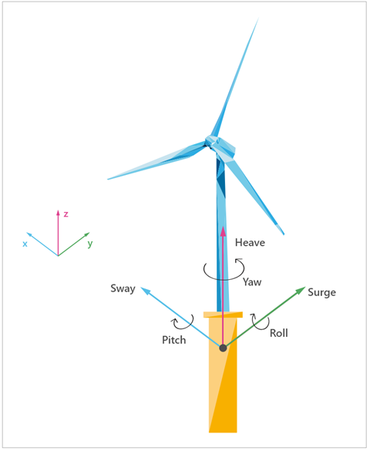
Figure 12: The degrees of freedom experienced by a FOWT

7.2 Integrated Load Analysis
The WTG controller runs algorithms which ensure the design limits of the overall system are not exceeded during any operational state and these algorithms are the intellectual property of the WTG OEM. It is therefore imperative that the insured explains clearly how the floater designer and WTG OEM were involved in the overall design process and the scope of any warranties in place, to ensure that the insurance cover takes into account any gaps between said warranties.
An integrated load analysis (ILA) must be undertaken during the design of the floater, mooring system, and WTG and the results incorporated into the controller algorithm of the FOWT. The variation in each design for the floating structure and the mooring system also complicates the algorithms of the structural controller for FOWT systems, adding risk that insurers must be mindful of.
The multiple input, multiple output (MIMO) systems involved in the ILA analysis are originally created in simulation software that differs per WTG OEM and cannot be developed without involvement of the WTG OEM. The validation of these models is a key factor in design and tuning of the controllers and therefore the initial results, re-designed controller algorithms and validation of these models must be investigated to confirm the controller’s ability to keep the WTG within its approved design limits and operational conditions. Obtaining third party approval of this process is preferred.
Simply scaling up controller algorithms from those used on smaller scale FOWT demonstrators is inadequate and the insured must provide clear evidence of the following:
- The WTG OEM has been directly involved in the ILA process and approved the final controller algorithms.
- A mechanical loads analysis has been completed for the project site by the WTG OEM which confirms the FOWT including its mooring system are suitable for the intended design life of the asset. Whilst it is more common for the WTG OEM to exchange load calculations at the tower base with the floater designer, it is critical that resultant loads from the floater and its mooring system on the WTG are then approved by the OEM to avoid WTG warranties being either overly restrictive, or invalidated. This coupled analysis between WTG OEM and floater designer should be covered by the certification process.
- Metocean site conditions were incorporated in the ILA based on data collected on site, including at least one winter period.

7.3 Load reduction devices
The added degrees of freedom (roll, pitch, and heave) in addition to surge, sway and yaw makes it a necessity for floating platforms to reduce the responses of the combined system. Load reduction devices (LRDs) lessen the dynamic loading from the WTG by dampening the load or by generating forces to enhance the structural response. These systems can be passive (such as tuned mass dampers or tuned liquid column dampers which require no energy) or active (such as active ballast systems which pump sea water around the floater to maintain tower angle and manage loads and optimise power production). The ability of active FOWTs to operate in periods of no wind and/or if cable connection is lost must be clearly outlined.

7.4 Testing
Commissioning and certification testing during the demo stages are critical to ensure structural integrity. For onshore WTGs, prototype testing is more equitable because the testing environment is easier to simulate (wind tunnels, controlled sites). Wave basin tests are a common form of scaled prototype testing, but it does not simulate the same load magnitude of real environmental conditions. To ensure the efficacy of the demo projects and eventually commercial distribution, wind, wave and current loads need to satisfy a wide spectrum of conditions. To truly understand the structural response of the FOWTs, the prototype periods should satisfy designated bin sizes along the normal distribution the WTG will experience in real time. Clear evidence of such testing must be considered by the classification society if applicable, and detailed to insurers if classification is not being sought.

7.5 Monitoring
To protect the drivetrain against the additional loading from the floating platform motion, proper monitoring devices and strategies need to be integrated into the FOWT system. Condition monitoring systems (CMS) are a standard in onshore and fixed-bottom OWF operation and can be implemented by the WTG OEM, or from third parties preferred by the owner. CMS is key to a preventative maintenance approach which may reduce the risk of failures and therefore insurance claims, as such detail should be provided on any CMS incorporated in the WTG. The addition of digital twin (DT) architecture to the CMS data can be used to compare performance between WTGs, predict the useable lifetime of the WTG and plan inspections or maintenance work. The implementation of this along with the standard CMS can offer long term drivetrain reliability at a relatively inexpensive cost for offshore floating technology.

7.6 Summary – Design of Wind Turbine
Concern | Recommendation
FOWT structural control efficacy not adequately demonstrated | Comparison of load results of computational models, operational data from demo, and re-tuned WTG controller
Drivetrain loads from excessive motion of FOWT could cause damage | Analysis of vibration data acquired by condition monitoring system and results of RCA from failures of demo projects
WTG is not a proven design | Provision of type certificate and key parameters/ limitations. Overview of operational hours logged from floating, fixed offshore or onshore applications and any upgrades the proposed model will benefit from.
Environmental conditions during demo project to validate computational models are not applicable to the risk being considered | Analysis of wind and wave load bins during demonstrator period, if available.
Unplanned outages due to drivetrain failures cause large business interruption claims | Information required on the capabilities of combining CMS system with data acquisition from digital twin model
Emergency operations not clearly defined | The ability of active FOWTs to operate in periods of no wind and/or if cable connection is lost (e.g. via back up power systems) must be clearly outlined.
Warranty gaps may exist if all relevant parties have not been involved in the integrated load analysis and resulting design choices. | Clarity on how WTG, floater and other warranties interact to provide protection for insureds against defective design, parts or workmanship
Dynamics of the combined system not clear – impact of variable Metocean loads (wind, wave and current) on the WTG, floater, moorings, dynamic cables and foundations (piles etc.) | Detailed dynamic analysis of the combined system and confirmation that dynamic loads are fully understood and mitigated and that fatigue of key components subject to cyclic loading is fully understood to ensure that the operation design life of the FOWT can be fully met (or realistic replacement times for specific components calculated). Evaluation of the cross-coupling of vibration modes when subjected to cyclic loading is an important aspect of this analysis.

Floating Offshore Substations
8.1 Overview
An offshore substation (OSS) is a critical asset in both fixed or floating OWFs above a certain installed capacity. The OSS raises the voltage of electricity generated by the WTGs to a level which reduces the current sufficiently to allow the cost-effective transmission of electricity to shore through the reduction of power losses.

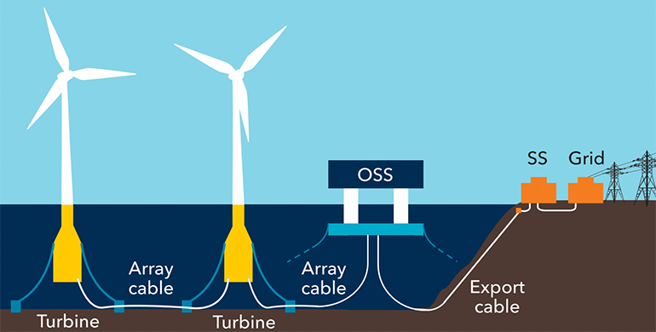
Figure 13: A FOWF incorporating a floating offshore substation and onshore substation (image courtesy of DNV)

The development of floating offshore wind technologies has been rapid in the recent years, with many concepts emerging. Following the successful deployment of prototypes and demonstration projects, the industry is now transitioning to commercial projects. However, while demonstration projects generate limited amounts of power that can be exported directly to shore or can be connected to already existing oil and gas assets, a commercial-scale project will require an OSS. The OSS will house a step-up transformer and the equipment necessary to export high-voltage (HV) power. The only floating offshore substation (FOSS) within a floating wind farm in the world was installed in 2013 in Fukushima, Japan, and is connected to 3 WTGs. The Fukushima OSS handles a total of 16MW and exports power at 66kV, which is not comparable to a commercial-scale wind farm.
Despite being crucial for the development of commercial-scale FOWFs, the development of FOSS designs has not followed the same pace as the FOWTs, since none of the projects deployed to date have a high enough installed capacity to warrant the need to step-up the voltage to minimise power losses. However, given the proposed installed capacity of some FOWFs now in the advanced development phase, it is imperative for the industry to focus on bringing FOSS designs to commercial and technical maturity.
A FOWF would typically be installed at depths greater than those which make economic sense for the OSS to be installed on a fixed-bottom foundation such as a monopile or jacket. Fixed platforms for oil and gas are economically viable for installation in water depths up to about 150 meters and for FOWFs located in such water depths, a fixed-bottom OSS (using jacket foundations) could limit the risks and costs inherent in new technologies. Crucially, a fixed-bottom OSS would enable static cables to be used for the export route, rather than high-voltage dynamic cables which have a far more limited track record, as discussed in section 5.
Subsea transformers have been proposed as an alternative solution for FOWFs where the water depth makes floating or fixed OSS uneconomic. No subsea OSS have yet been deployed for floating wind and whilst a track record exists from oil and gas, the use of subsea transformers for FOWFs is likely to require significant development and testing due to the far higher voltages involved and complexity of carrying out repair work on such systems underwater.

8.2 Different floating substructure concepts
The different concepts envisaged for FOSS foundations and mooring systems are similar to the designs used for floating oil and gas or WTGs: semi-submersibles, tension leg platforms (TLPs), barges or spars. In all types of floating foundations, different types of anchoring can be used depending on the type of mooring system, soil condition and expected environmental loads.
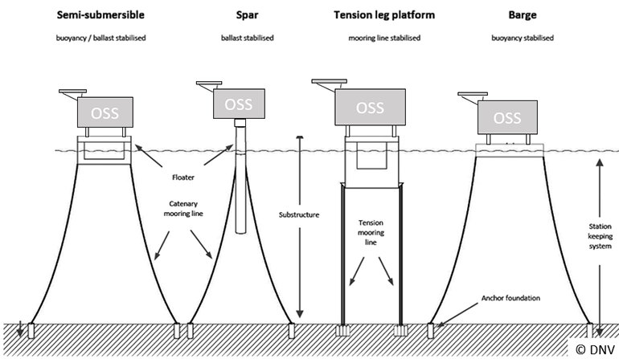
Figure 14: Different concepts of Floating Substations (image courtesy of DNV)

The FOSS will have different design limits to WTGs or oil and gas assets that will drive the design. The weight of the topside of the FOSS, its center of gravity and distribution is very different to the characteristics of a WTG or oil and gas assets. These properties have a direct impact on the stability, dynamics, and maintenance of the substructure, requiring a specific and individualized design. In addition, a FOSS has a multitude of underwater cables connected to it. A typical project array might have more than ten array cables and at least one export cable running from the FOSS to the onshore substation. This dense subsea cable configuration is very sensitive to large displacements, and excursions of the FOSS too far from its original position can damage the cabling. The EML scenario associated with an OAR policy is likely to involve the loss of either the export cable, or a key component of the OSS which precludes any power generation until repaired or replaced. Therefore, the insured will have to provide strong evidence that the mooring system and cables associated with the FOSS have been subject to the same robust design and operational considerations discussed in Chapters 4 and 5. In the absence of this, insurers are likely to consider the risk of such an EML scenario occurring to be significantly higher than for a fixed OSS.

8.3 A combination of proven technologies and innovations
Experience from oil and gas and maritime industry on floater concepts, station keeping systems, ballast systems, and other equipment, can be transferrable to FOSS.
Some floater configurations, such as TLP, have significantly reduced motion in some degrees of freedom. However, all floating platforms are dynamic systems that move. This dynamic behavior of a floating installation is a design challenge compared to fixed OSS. And while most components of a FOSS are proven technologies from the oil and gas or marine industries, two issues that require considerable innovation are high-voltage underwater dynamic cables and high-voltage equipment. The OSS floating substructure must therefore be designed to have motions and accelerations that will not compromise the operation and design life of the HV equipment and dynamic cables attached to it. To achieve accurate conclusions on motions and accelerations of a FOSS through simulations, it is imperative to follow an integrated design process that includes all requirements and limitations for the three technology groups: floater, HV equipment and dynamic cable.
To connect the FOSS to shore, the HV export cable must be at least partly dynamic in design, as it will connect the moving FOSS to a junction or joint with the static export cable laying on the seabed. Unlike standard HV submarine cables used for fixed-bottom OSS, dynamic cables must be able to accommodate the extreme displacements of FOSS during storms and have sufficient fatigue strength to handle a lifetime of cyclic motions (>20 years). This type of cable exists for voltages up to 66kV, but is still under development for the higher voltages required for power export in commercial scale floating wind projects (typically ≥ 230kV for AC, and ≥320 kV for DC). In dynamic cables the water barrier must limit moisture ingress and provide enough fatigue resistance during the project lifetime.
Due to historical lack of demand in the market, there is a lack of knowledge about the qualifications required for HV equipment operating in dynamic environments. HV equipment, especially the power transformer and the gas-insulated switchgear (HV GIS) have not been designed for repetitive accelerations, large motions and long-term exposure to fatigue cycles that will result from operating on board a FOSS, at the voltages required by the next generation of FOWFs. It is however noted that some floating oil and gas platforms take power from shore via dynamic cables of 100 kV and higher from which valuable insights may be gained for FOSS design.
It is expected that existing codes and standards can be used as a design basis and that the first commercial FOSS (including topside, equipment and substructure) will be designed following a risk-based approach in an iterative manner concluding on a solution with an acceptable cost that meets the target safety level. However, new innovations to reduce uncertainties around HV equipment and dynamic cable may require qualification and testing in real environments before implementation in commercial-scale projects. This testing phase must be of a sufficient duration to gather relevant and reliable data, which might conflict with the expected timeline for implementation of these new solutions in the first commercial floating wind projects.

8.4 Further design development
Similar to a FOWT, a FOSS requires of several innovations, each of which introduces additional risks and costs, particularly for front runner projects. However, there are strategies to mitigate these inherent risks and instil confidence in developers, investors and insurers alike. These strategies include:
- rigorous testing and certification of critical components to ensure alignment with industry best practices and design criteria, reducing the risk of failure. While the development of relevant-scale FOSS prototypes within a relevant timeframe may be challenging, individual critical elements can be tested using industry-standard testing techniques like dynamic testbeds or basin model testing.

- the implementation of a high degree of remote monitoring on the FOSS once operational to maximise system availability. This condition monitoring can be applied to any critical element such as mooring lines, cables and HV equipment. Moreover, this monitoring will enable predictive maintenance and therefore reduce operation and maintenance costs and reduce risk of catastrophic failures.
DNV has led a joint industry project (JIP) on FOSS to develop new solutions, standards and recommended practices on these technologies. The first phase of this JIP concluded in the second half of 2023 with the participation of 38 industry partners. This first phase explored the feasibility of FOSSs, identified technology gaps and affirmed the maturity of alternating current (AC) over direct current (DC) solutions. The results and conclusions on this JIP will contribute to the update of DNV’s industry-accepted standard for OSS. A second phase of this FOSS JIP is in the initiation phase at the time of writing this guideline. The ultimate objective is to support the scaling of floating wind with an acceptable level of technical, commercial and HSE risk, through robust guidelines developed in partnership with the industry.

8.5 Summary – Floating Offshore Substations
Concern | Recommendation
Floating substations are feasible, but whilst HVAC is more mature than HVDC, HVAC experience on floating structures from oil and gas does not cover the voltage and power capacities needed for FOSS. | Development of new solutions, standards and recommended practices for FOSS must be tailored for FOWF voltage levels and capacities. Information sharing via a JIP approach is likely to benefit all stakeholders.
Technology needed for HVDC FOSS is not yet available. | Early engagement with insurers to gauge their appetite for insuring HVDC FOSS is recommended, until HVAC FOSS has been successfully deployed at scale.
There is a need to close technology gaps and qualify technology | The IVB should carry out a gap analysis at the conceptual design phase of the FOSS and identify a route to technology qualification
It is required to establish a good design process integrating floater, HV equipment and cable | Suppliers of the HV equipment should be fully integrated in the design of the foundation and topside of the FOSS
Lack of comprehensive standards addressing FOSS requirements | International standards are being currently updated to include state-of-the-art requirements for FOSS and its components
Current safety classes assigned for FOSS do not reflect the potential loss of revenue associated with a failure | Relevant stakeholders are in discussions whether there is a need to update safety Class for FOSS. Safety Class has a direct impact on the design philosophy and therefore the design.

Marine Warranty Surveyor

9.1 Overview
The Marine Warranty Surveyor (MWS) is appointed on an offshore construction project by the insured, but acts on behalf of underwriters in accordance with the Marine Warranty provisions in the slip, to ensure that good offshore marine practice is followed and that the marine operations are conducted with acceptable levels of risk. Insurers typically agree to partially fund the MWS employment with an engineering allowance which is funded by a RP (returned premium) to the insured and organised by the broker, typically a percentage of the gross written premium as incurred. If this allowance does not cover the full MWS costs additional costs are typically be borne by the insured to ensure the Scope of Work is fulfilled. In broad terms the MWS’s scope of work includes:
- Approval of documents and installation procedures provided by the insured
- Suitability check of the proposed vessels, tools and equipment
- Attendance during key parts of the installation (‘first in series’)
- Attendance at meetings with the insured and contractors as required

MWS Guidelines have developed since the 1960’s and early 1970’s when the concept of the Marine Warranty Surveyor was developed. Noble Denton (now DNV) was the first to develop guidelines which have been systematically updated since then and have now been absorbed into the DNV documentation system. The guidelines of other companies largely spawned from these original guidelines. Apart from some divergence most guidelines follow similar practice. Many smaller companies use the guidelines developed by one of the larger companies over the years. MWS guidelines cover critical marine operations and are guidelines, not rules. Definitive judgements on their application are, therefore, left very much up to the attending surveyor. However, other codes for, for instance, structural integrity and design, Classification Rules, national and international requirements and laws, must be accommodated on projects and, in this respect, the general approach is that most standards, codes, rules and guidelines are acceptable provided they follow good industrial practice and are recognised as such.

9.2 Scope
Instructions on the extent of the MWS employment comes from the insured and the underwriter advises the insured on the Scope of Work required for any particular project. The Renewables Scope of Work which covers FOWF has been developed by the JNRC based on the Upstream Construction scope of work originally released in the early 2000s. The most relevant documents for FOWF are listed below.

Name | Issued: | Version
JR2021-028A Renewables Warranty Endorsement | May 2021 | 1
JNR2023-029 Renewables COP SOW COA  (SoW 3 refers to Floating Offshore Wind Farms. SoW 4 refers to Subsea Cable Installation) | February 2023 | 2
JNRC 2023-041 Offshore Wind Farm Survey Guidelines | June 2023 | 1
JT 2019-010 MWSC Pre-Qualification and Good Practice | September 2019 | 2

The above documents are free to download and distribute from the following address:
https://www.lmalloyds.com/LMA/Underwriting/Marine/JRC/scope_jrc.aspx
Reference should also be made to the forthcoming LMA document: ‘Marine Warranty Surveyor Appointment Rev. 07’ at the same website address once published later in 2024.
These are live documents and are periodically subjected to being updated, modified and corrected. At present the Scope of Work requirements for the FOWF installation are relatively general but, as the industry develops and good practice established, these documents will become more comprehensive in their scope. For example the towage element for FOWT is currently being developed as this has become a requirement for not only installation but also for repairs of existing units.
After considering the project requirements the underwriter prepares a draft Scope of Work, which should be JNR2023-029 Renewables COP SOW COA or similar or decides on the attendance required to satisfy the underwriting requirements. This, together with the Code of Practice associated with the Scope of Work is passed through the broker and insured to the MWS who bids on this document and, if successful, uses it as a basis for attendance.
It should be emphasised that the Scope of Work is a framework for what is required allowing for some flexibility for the document to be tailored for specific risk considerations on the project. This is because the underwriter (or even the insured), at the time of providing cover does not know every detail regarding how the project will proceed or develop. If the MWS is appointed by an EPCI contractor on a large project for example, any changes to the MWS scope following contract award may result in the issuance of a VO (Variation Order).
The purpose of the Marine Warranty Scope of work is to cover the temporary phases relating to the load-out, transportation, and installation of the offshore asset. These are nearly always the marine aspects where the maximum value of assets are at risk. For marine operations these include:
- Loadouts: lifted, skidded, floated, trailered or launched.

- Sailaways: In the case of FOWT these will nearly all be tows by tugs or transportation using HLV’s (Heavy Lift Vessels).

- Lifts: Lifts above a certain weight or value using either onshore or offshore cranes or heavy lifting equipment.

- Temporary Moorings: floaters and completed FOWTs will be required to be moored temporarily at quaysides for integration and commissioning and, also, in storage locations.

- Offshore installation: Hook-up to the moorings and connection of the dynamic cable.

- Cable laying: Cable laying (usually initiation, termination and crossings) including trenching and burying, and wet storage of cables prior to trenching.
The MWS could and does sometimes also cover road, air and rail transportation of components. As the MWS surveyor oversees these operations all the time they are usually much more experienced in these critical activities than the rest of the project teams. They also have wider experience having worked in many yards, countries and offshore locations. Their expertise is, therefore, extremely valuable and can greatly assist the project team in ensuring a successful operation.
Consequently, the underwriters also value their presence, looking after assets insured by them, as they are the only presence on the ground and they can quite rapidly report back to the underwriters (contract permitting) any problems encountered. The nature of OWFs, in general, means that it is economic and probably justified for the MWS to take a risk-based approach to attendances and attend only the first few of a series of many almost identical installations. Once the MWS has confidence that an established method is being practised successfully then a repeat Certificate of Approval (CoA), also known as a Certificate of Repetition, is issued for similar operations. If there is a problem or it is discovered that the operations are varying from the agreed procedure the CoA can be cancelled, withdrawn and the MWS re-attends to witness the ongoing operations.
The MWS usually attends alone but IVBs associated with the project certification or Class process (see section 3) may also be present and engage in some of the operations in their own role. The MWS performs a discrete role which is independent of Class and certification and this must be respected by the insured and IVB. The aim of the MWS during the transport, installation and operational phases is to verify that all operations are undertaken in accordance with design and metocean limitations. The MWS will only issue a Certificate of Approval for a specific marine operation if that is the case and any non-conformance / or non-compliance could have a significant impact on insurance coverage. The aim of classification/certification bodies during these phases is to verify that all operations are undertaken in accordance with design, and any non-conformance / compliance is reported. It should be noted that there is some overlap with the role of the Marine Warranty Surveyor (MWS), however, the IVB’s remit on site is one of observation and reporting and is not directly associated with the execution of operations.
Therefore, the use of the MWS on FOWF construction projects is regarded by insurers as essential. Given the extra steps involved in the construction of a FOWF, insurers will be keen to see insureds engaging early with the MWS to head off questions or concerns the MWS may have with any novel practices being proposed.

9.3 Qualification
Until recently most Marine Warranty Surveyors were required to be professionally qualified within their discipline (Master Mariners and Chartered Engineers, for instance) but there was no formal qualification to specifically address the role of a Marine Warranty Surveyor. This changed in 2017 with the establishment of SOMWS (Society of Offshore Marine Warranty Surveyors). This sets qualifying criteria for an individual MWS to become qualified in one or more of four categories of warranty surveying:
- Oil and Gas Projects (SOMWS category designation “P”)
- Project Cargo (SOMWS category designation “C”)
- Renewables Projects (SOMWS category designation “W”)
- Rigs MODU (SOMWS category designation “R”)

Associate membership is also an option for younger MWS practitioners, which is valid for a maximum of 5 years, after which an Associate member is either expected to become a full member after obtaining sufficient experience or withdraw membership. It is a temporary category.
Underwriters generally require the MWS to be SOMWS qualified.

9.4 Contingency
A contingency plan should be provided for each of the main offshore operations involved in the installation of the FOWTs. This should include as a minimum safe harbour options should weather prohibit the planned operation and alternative vessel options.

9.5 Summary – Marine Warranty Surveyor
Concern | Recommendation
The methods and techniques applied in the floating wind industry are relatively new. Without an on-site representative to ensure best practice is carried out and their interests are being sufficiently monitored, insurers are limited in their ability to assess whether poor practice is being employed on site which could result in a loss. | The MWS should be appointed on all FOWF projects as early as possible. Experience passed back to underwriters will be used to make more informed choices regarding future cover and insurance rates.
The nature of marine operations is such that contingency plans are always required. Unlike most land operations work at sea cannot just stop. There must always be a plan for responding to a problem be it weather, equipment failure or another accidental situation and to leave a project safely. | Contingency plans should be provided for review by the MWS.
Does the proposed MWS (the individual) have minimum qualifications for the work undertaken to adequately look after the underwriter’s interests? | Marine Warranty Surveyors should be SOMWS qualified.
MWS Company being inexperienced or not qualified. | MWS companies should be able to fulfil the requirements of the JT-2019-010 MWSC Pre-Qualification and Good Practice Guideline (Version 2, September 2019).  Underwriters to communicate acceptable MWS companies to brokers.  To ensure there is a baseline of minimum MWS standards and expectations reference should be made to the JNRC guidelines available on the LMA website. The approach should be ‘the right MWS Company for the right project.’ Ideally underwriters should agree a panel from which the MWS is selected to ensure that the MWS Company has the right level of experience and resource. In some cases the MWS is appointed before underwriters are on risk which can result in a non-preferred MWS selection.
Lack of clarity on the required scope of work. | The MWS Scope should be informed by and based upon JNR2023-029 Renewables COP SOW COA

Construction Phase (Onshore Works)

Overview
Some of the highest risk operations during the construction of an FOWT will be the upending and lifting of the WTG, the handling of components which are to make up the final foundation and the launch, loadout or floating out of the completed floater.
This section covers all elements of the construction phase carried out onshore, namely fabrication and assembly of the floater followed by integration of the WTG with the floater. This often requires yard facilities with deepwater quaysides and large cranes to perform the lifts especially for the tower, nacelles, and WTG blades.

Relevance to insurance coverage
Fabrication and assembly for a FOWF includes several transitionary phases. It is important to agree the date of inception (on risk) for various main components onto the CAR policy. This will depend on the arrangements of underlying sub-contracts. However, typically, the following could be envisaged as points of inception onto a CAR policy for a FOWF project:
Floaters: At the inception of construction at the floater assembly site.
This is typically the final site of assembly of the floater for the FOWT. For example, sub-components, such as columns and trusses, are often fabricated at other sites, typically the CAR cover does not include the transportation from such sites to the final assembly location of floater. However, this will vary depending on developer and contractors' requirements and insurers agreement. Final assembly site of floater does not need to be the same site as the site of integration of floater with tower, nacelle and/or TP.

WTGs: Typically when departing for, or arriving at, the port of integration with the floater.
It is important here, if two MWS companies have been appointed, to understand which MWS will be responsible for which part. This should be decided well in advance and clearly stated to insurers at submission. Loadouts and associated activities (storage, logistics, tug availability etc.) are also important to define.

Cables: Typically from the issuance of final FAT certificate for the cable system. This means that any handling or storage of the cables after final FAT may be covered by the CAR policy and therefore requires oversight by the MWS. Cable components usually have many interim FAT’s, the results of which should all be provided to the MWS for review upon request. The inception point, in these instances, should be when final FAT approval is complete for a cable. For other ancillaries inception should occur when they have passed the FAT and are clearly marked for the project.

Substation: The fabrication or building of substations is usually part of the CAR policy as is the transportation of the FOSS topsides and floater to the installation site. This is not usually true for items fabricated or manufactured prior to the commencement of work at the OSS fabrication site.

For assets having cover for prolonged transportations, which could include War and Cargo coverage, particularly in areas requiring transit through high-risk areas such as the Red Sea (Suez Transit), a clear overview of potential mitigations should be made clear. For example, a risk assessment for a transportation around the Cape of Good Hope should be done by an MWS to ensure weather limits are addressed and good securing and transportation practice is followed.

The above list will vary depending on the type of design and material chosen for the floaters.

  - Fabrication
Fabrication is here defined as the stage where components are manufactured into their final form. However, for a FOWF there will be stages of transport and handling (installation) prior to final assembly (integration). Fabrication includes the RNA of the WTG, the WTG tower, the floater, the mooring system and the cables. It is noted that the fabrication of an RNA actually involves the assembly of multiple sub-components which have themselves been fabricated elsewhere. For example, the blades may be fabricated at the OEM’s blade factory, the gearbox fabricated by a supplier at their factory and the nacelle and bed plate fabricated at the WTG OEM’s facility. The blades and remainder of the RNA are typically transported separately to the integration location for assembly prior to integration with the tower and floater, and covered in a Marine insurance policy.
Fabrication of steel floaters may involve panel construction which can be largely automated, as well as tubular sections which may be used to provide efficient strengthening braces. The steel structures may still require the rotating of pre-fabricated blocks for the floater to enable as much downhand welding as possible, Downhand welding is generally faster, more reliable, can use a higher current resulting in greater weld deposit and can be carried out by less qualified welders. However, welding tubulars together (6G welding around elliptically shaped deep penetration welds) requires considerable skill and can be slow. Improved productivity can be achieved by increasing the number of accessible work faces. This means that blocks can be fabricated at multiple locations either in the yard or elsewhere. This requires the greatest simplicity in the design especially because the skill levels may be variable across different companies. These considerations all have a bearing on the ability to meet required levels of fabrication quality assurance, which is a focus of manufacturing surveillance carried out as part of a classification or certification scheme.

10.3 Floater assembly
During assembly, the floaters are assembled from parts fabricated, at various locations, into one unit. This process will depend on a detailed Inspection and Test Plan (ITP). Integration typically involves the assembly of the tower sections on a floater, installation of the nacelle on top of the tower and connecting the blades to the hub. Both the assembly, as well as integration stages, may require significant arrangements for inshore temporary moorings. It is recognised that, as the industry develops, operations will adapt and become more efficient, the operations outlined here are, therefore, intended to present a framework against which individual projects can be assessed to ensure that key baseline considerations are considered.
Different floater designs will require varying levels of construction at the assembly port prior to integration of the WTG. The insurer must be provided with information on the draught and space requirements of the floater and the environmental limits placed on the assembly process. An example of some of the considerations are tidal range, susceptibility of the port to swell, suitable mooring locations and wind limits, especially for large land-based cranes. Evidence must be provided that the port chosen enables these requirements and limits to be met with no risk to safe execution.
Current general assembly assumptions for each floater type are that they will be fabricated and integrated in one yard with the possibility that large, prefabricated components are transported, largely by sea but also by road, from other fabrication yards for final integration. If the floater needs to be towed from the main fabrication yard to a second yard for integration with the WTG (for instance due to lack of a suitable crane or quay space at the former), this adds risk and expense to the project and will also require MWS attendance.

10.4 Floater loadout / float-off
The method of floater loadout should be stated along with all associated operational limits, this may include:
- Loadouts conducted directly into water (slipway launch)
- Crane lift into the water from a quayside.
- Loadouts first onto a barge, pontoon or floating dock which is then submerged. This two-step process increases the risk but allows more control of weather risk
- Vessel lift using a Synchrolift or similar
- Float-off. Spar floaters with large draughts are typically floated out horizontally and then righted by ballasting in deep water either at the port or a sheltered location elsewhere.
10.5 Integration
The process of integration involves lifting the WTG components from the quayside onto the floater and completing any topsides structures and fitting out. It is assumed that the floaters are moored alongside a quayside with suitable under keel clearance for this process, however some spar concepts may first be towed to deeper water in a horizontal position, then upended ready for WTG integration.
Key elements of interest to the insurer during integration are as follows:

- Interfaces: The integration of the WTG will be the key interface and is likely to be handled differently for FOW than for fixed-bottom, as shown in the diagram below:

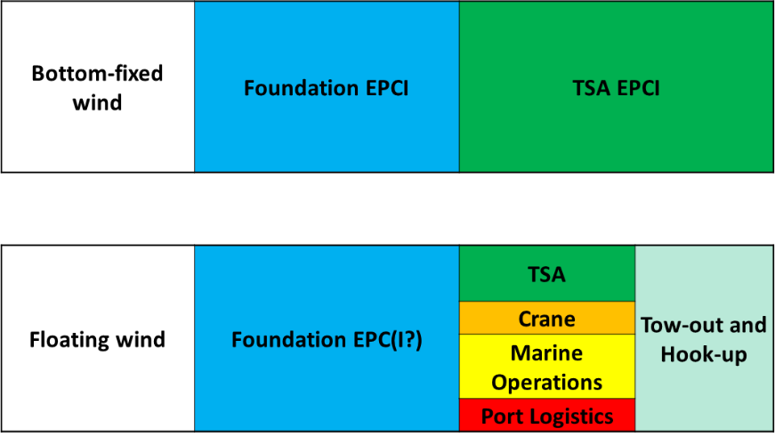
Figure 15: Key interfaces for construction packages

- Weather restrictions: Weather is one of the main considerations, especially with respect to wind limits for cranes and wave, current and tidal restrictions for alongside operations.
- Stability of the vessel: Vessel stability during all stages of construction, installation and operations is critical both intact and damage. Survival after one compartment damage would be expected as a minimum survival condition.
- Motion response: The FOWT motion responses both alongside, particularly during the tow and also during operations is critical and complex. Everything moves and there are multiple harmonics, some constructive some destructive. A full examination of critical motions would be expected during the design of an FOWT.

Craneage
Appendix B lists the minimum information required by underwriters to get an initial and quick understanding of a FOWT construction project. Craneage is included but it is of such importance that additional information should be provided (see 10.7)

10.7 Summary – Construction Phase (Onshore Works)
Concern | Recommendation
Uncertainty of lead time for components . | Clear overview of the schedule for the CAR policy, especially for all the major components.  Include overview of all insurance cover (PD, DSU, LOPI, BI, CBI etc.)
No overview of the overall quality control plan. Gaps may exist between the (Quality Control (QC) plans of designers, contractors, fabricators and manufacturers. | Project Quality Management to include as a minimum:  - Concise overview of QC procedures required.  - Adequate numbers of qualified QC personnel to be assigned to critical fabrication sites.  - Demonstrable use of previous experience to be absorbed into projects.  - Attendance of project QA/QC inspectors at critical tests including FATs and SITs.  - Handling of NCRs.  - Approval of repair procedures
Uncertainty in onshore construction methods being used and operating vulnerabilities | Provide clear description of methods for each phase of onshore construction.
NCRs that have not been reported or factored into construction procedures | Leading insurers should be informed about NCRs that occur as well as how they are closed out. The information should also be provided to the MWS when reviewing the handling procedures being proposed. Monthly progress reports should include a list of non-conformances.
Unrealistic schedule, based on availability of contractors, weather windows and overall scale of the works. | Schedules for fabrication should be provided in GANTT style.  Critical path for long lead items should be identified and have float/contingency included in the schedule to prevent delays.
Details of assembly and integration locations not clear. Potential risk of foreseeable hazards causing a loss. | Assessment of fabrication yard, harbour facilities (quayside capacity and suitability, water depth, sheltered location, craneage, mean temperature, routes into and out of harbour to open water and air gap restrictions).
Repetitive defects in similar units. | Examine schedule and fabrication methods to establish cause of defects.
Losses during temporary environmental conditions (loadouts, for instance). | Establish a clear overview of major transitionary phases and examine the following in detail:  - Major moves and loadouts; method of execution, robustness and redundancy.  - MWS scope of work should clearly state which of these phases will be reviewed and/or witnessed by the MWS.
Unsuitable locations where insured assets will be handled. | Provide overview of suitable locations for fabrication, assembly, integration as well as vessels or vehicles to be used for transportation between locations. Verification of suitability of locations for intended operations.  Summary of the exposure of these locations to inherent and non-inherent risks.
Lack of clarity around inception points and MWS involvement during transitory phases. | Establish a clear understanding of the phases of the CAR policy compared to the MWS SoW and the schedule, including intermediate phases. Clarity of which items / assets are provided as ‘free issue’ to the project, and at what point they are to be provided
Uncertainty as to the applicable maritime zone. | Project should provide clear and detailed maps showing maritime zones and understand particular requirements for the zones to be transited and the requirements at the final site.
Lack of details regarding cranage. | Information should be provided on:  - Who has contracted the Crane Owner?  - What is call-of notification window for Crane Mobilisation?  - Who is responsible for which part of the integration? (Typically, it is organised by the WTG OEM, but not their explicit responsibility as Crane and all other facilities are provided by others).  - How many alternative cranes are available of this type?  - What are the environmental limits for crane operations (particularly wind speed)?  - What is the crane mobilisation period?  - Is a general framework being discussed for this crane for MCE?  - Is a similar general Framework Agreement (FA) being discussed to acquire smaller cranes for Main Component Exchanges (MCE) of smaller or lighter components. For instance, for lifting gearboxes and generators.

Construction Phase (Offshore Works)

11.1 Overview
This section covers the main marine operations associated with construction, including:
- Wet storage and towage to wet storage location.
- Pre-installation of mooring systems
- Towage of FOWT
- Hook-up of pre-installed mooring system.
- Cable Installation
- Commissioning of FOWT.

Assessing the scope and quality of the offshore T&I activities of a project is key to understanding the risks involved.

Wet Storage - Temporary Mooring
Temporary mooring of the floater and the completed FOWT is known as wet storage and will be required unless tow-to-site scheduling and space at the integration port allows otherwise. The wet storage area may be some distance from the point of Integration. The duration of time each integrated FOWT will spend in wet storage must be clearly stated, along with what arrangements will be made for:
- Temporary mooring. Temporary mooring arrangements should be subject to MWS review according to recognised marine operations standards. An assessment of the collision risk between multiple FOWT units moored near each other should also be made. Failure to do so could result in a complete loss of one or more FOWTs should the mooring system fail.

- Temporary power. This will be required unless the FOWT is able to self-power auxiliary systems such as yaw, pitch, brakes, SCADA, heating and cooling if power is not available from slow rotation of the rotor. Without power to such systems damage can quickly be done to the blades and drive train even in moderate winds. In storm events such systems must be powered to avoid the potential for a total loss. Temporary power sources are typically mobile diesel generators which require careful placement and maintenance.

- Maintenance. Details of the WTG and floater OEM’s minimum requirements for maintenance of the FOWT prior to commissioning on site must be clarified. This is considered relevant for all stages following the integration of the WTG with the floater. If the warranties associated with the FOWT and its mooring system incept at the point of wet storage as opposed to commissioning this puts even more emphasis on the need for a robust storage plan.

These challenges are exacerbated if a prolonged period of wet storage is required, especially, for instance over a winter period in the North Sea.

Pre-installation of Mooring System
The mooring system is pre-installed prior to the tow-out and hook-up of the floating unit. Depending on the logistics of the operation, it is likely that the pre-installation of anchors and bottom sections of the mooring lines can be installed up to a year prior to the first FOWT tow out. Significant logistical coordination will be required to handle the large volumes of mooring components. Strict handling procedures must, therefore, be enforced to avoid delays and damage.
AHTs will nearly always be required for mooring installations including their pre-tensioning during hook-up. At some locations, the pre-tensioning loads may be considerable due to the FOWT size and water depth, and limit the choice of AHTs.
Mooring line composition has a significant impact on handling complexity, installation and risk of damage during temporary storage. For example, the frequently used spiral strand wire is a significant component of the mooring system. However, during installation it can be demanding and time consuming to handle where any over bending has to be avoided and careful handling required to prevent bird caging, kinking and compression. Load reduction equipment can manage these situations. Compared to FPSOs, FOWTs are less likely to be fitted with winches for mooring system tensioning and adjustment. In these circumstances, inline tensioners, heavy chain sections or clump weights on the mooring line can be used instead.
Insurers must be informed of the spread complexity and execution of the installation process. A dialogue around how “standard” the installation is and, therefore, how readily available alternative vessels, equipment and crew may be is hugely beneficial. For example, there may be a significant waiting time to access suitable piling spreads for a weather-sensitive summer operation, whereas AHTs can perform a drag-anchor installation more easily. One is a construction activity requiring specialised personnel using expensive and scarce vessels, the other is a task requiring more conventional vessels, crew and equipment.

Towage and mooring hook-up of FOWT
Tow out and hook-up operations must consider the location, towage length, season, schedule of activities, complexity of the moorings and also have sufficient redundancy in the tow spread to avoid risking any tow with a single vessel failure.
Adequate towing points will be required which should either be Smit brackets or similar quick release towing points fitted to the FOWT or connections made to the existing mooring points using the fairleads. It is beneficial if the towage contractor is in direct dialogue with the design and fabrication team to ensure good practice is followed for both installation and possible future disconnection and reconnection.
One tug with a reasonable bollard pull (greater than 100t) should be adequate for towing most units in reasonable weather, if the towage is in relatively favourable weather. However, control of the tow may require assistance leaving the port using harbour tugs and at least two AHTs will usually be required for connecting to the pre-laid anchors offshore. For long tows more than one main tug may be required, if distance, fuel, limited sea room, navigation requirements or adverse weather become significant risk factors.
The towage contractor will specify the towing requirements, but details of emergency towing arrangements must be provided to insurers. This should include an emergency towing line being connected to the floater and trailing a floating, buoyed, pick-up up line behind the unit.
Mooring line hook-up involves the safe retrieval of mooring lines, connection to the FOWT, appropriate tensioning and installation of any ancillary elements. Any requirements for temporary buoyancy during this transition stage (e.g. for TLP designs) must be clearly articulated, and emergency response plans created should stability be lost.

Cable Installation
For cable installation, operations should adhere to the IMCA Code of Practice for Offshore Cable Laying in the Renewable Energy Industry suitably amended by requirements for the dynamic aspects of the project.

Transportation of dynamic cables requires a different approach to a static cable, with different carousel limits. Similarly, dynamic cables must be deployed with care and cannot, for example, be deployed over the stern roller of an AHTS. For all cables, the limits to spooling and unspooling should be clearly stated, referencing the proposed dry storage, load out and installation strategy. Cables are generally expected to be wet stored at the project site prior to their termination, which represents a risk of both water ingress and the potential for vessels or their anchors to damage them, whether the cables are held in the water column or left on the sea bed. Clear risk mitigation strategies must be provided, including the marking via surface buoys and the use of Automatic Identification System (AIS) to alert ships to their whereabouts. The operational limits of endcaps and ancillaries associated with the wet storage period must be appropriate for the worst case.

  - Cable termination and commissioning
Until experience is gained in the termination of cables at FOWTs, and models verified and streamlined as a result, the cable termination phase should ideally be carried out with representatives from the cable OEM, and ancillaries OEM in attendance. This is likely to ensure the following:
- Limits are not exceeded (such as minimum bend radius)
- Connection of ancillaries are as per specifications
- Vessel operators are fully briefed on the deck storage requirements and interfaces with diving or ROV operations when cables are being brought up from temporary wet storage, tied off and then terminated.
The termination of cables – whether dry mate or wet mate – should be clearly outlined, and the experience of chosen termination contractors provided to insurers. Many elements of the cable termination process require divers instead of Remotely Operated Vehicles (ROV), increasing the risk of injury. This is a key consideration should a liability policy also be required for such operations.
A full list of all parties involved in the termination, commissioning and testing of all cables should be provided, along with their relevant experience working on FOWTs.
This is a critical phase and typically involves a number of tests, including:
- AC Voltage Test
The AC voltage test or Frequency-tuned resonant (ACRF) test is one of the most widely used technology for power equipment diagnosis. Typically it is carried out for 1 hour and also involves the recording of partial discharge (PD) and Tan Delta values. Partial discharge occurs in gas filled cavities or defects in the cable insulation and a failed PD test means costly remedial work to one or more cables is required

- Line Resonance Analysis (LIRA)
LIRA relies on the correlation between insulation’s condition and its dielectric constant (mainly capacitance) and calculates the impedance spectrum (amplitude and phase) as a function of the applied signal over a wide frequency band. LIRA can be carried out on electrical cables hundreds of kilometres in length and is becoming increasingly effective for fault location on OWF cables. LIRA can test for and detect numerous types of faults and defects in insulation including temperature and radiation damage, moisture ingress and mechanical impact to name a few.

- Optical Time Domain Reflectometer (OTDR).
See section 5.7 for an overview of OTDR.

- HV Resonant Test
Rather than applying a nominal voltage like a soak test, a resonant test reproduces the load on a cable operating normally at normal voltage and grid frequency and can detect numerous types of faults and defects. The test is carried out using a resonant circuit made up of a test inductor (inductance) and a test cable (capacitance) which requires additional vessel-based equipment to soak testing . It can test multiple IACs on a string of FOWTs at a time and is seen as a gold standard for cable testing.

If subsequent to cable installation there will be a significant period of wet-storage, potential continuous access to DAS or similar should be outlined. It is highly advantageous to know that there has been a damage, potential strike, to a wet-stored cable prior to hook-up of such cable so that one repair and hook-up campaign can be scheduled instead of two, both with regards to loss of revenue as well as cost of repairs. The insured should also state how much overlength is in the cable for cutting out, should a seal leak during wet storage, and how this length has been calculated e.g. through water ingress testing.

11.7 FOWT commissioning
During the WTG commissioning period, it is important that the wave and wind conditions are monitored throughout their testing periods. In fixed offshore wind, the WTG OEM will require 240 hours of fault free operational time to consider the test phase completed during commissioning. Unless specified by the owner and/or the WTG OEM, the environmental conditions (wind and sea state) are not mandated to be within any specific range during commissioning and may be restricted purely by the operational limits of vessels required to be on stand-by during commissioning or the presence of personnel on the FOWT. This can result in testing periods that have low wind, and not necessarily producing through its full range of MW output. With the addition of unpredictive wave loads, this adds to the complexity of simulating a full spectrum of operating conditions that the WTG controller will have to respond to. The longer the commissioning period, and more representative the environmental conditions experienced, the more certainty is imparted to insurers and insureds alike that installation has been carried out to specification and the commissioned FOWT is behaving as intended and modelled in the ILA process discussed in section 7.
Such information should be clearly provided since it is crucial to the transfer from a CAR to OAR policy. This should be clearly explained in the insurance policy and may relate to whether WTGs are ‘taken over’ by the insured’s operations team one by one, or one string at a time, or only once the entire FOWF has successfully completed its commissioning testing.

Risk Management during marine operations
The insurer must be afforded an understanding of the philosophy of the developer and contractors chosen (or short-listed) with regards to approach to risk-management for marine operations. The risk-management process starts at concept design or FEED stage with high level risk assessments identifying problems and mitigating actions to be implemented using SIMOPS, HAZOPS and HAZIDS. It is expected that each construction package contract will specify the standards required (e.g. the recently updated DNV-ST-N001).
Project risk should be controlled using various mechanisms; design reviews, construction reviews, HAZIDs, HAZOPs, SIMOPs and other marine readiness reviews during engineering and planning. Offshore operations will require project familiarisation, Safe Job Analysis, Toolbox Talks, Shift Briefings and Work Permits and review of two or more independent weather forecasts to compare against the operational limits stated. Deviations to approved procedures will be subject to Management of Change procedures and new site risk assessments. Review of the above should be within the scope of the MWS.

Summary - Construction Phase (Offshore Works):
Concern | Recommendation
Choice of design and materials | Proper testing and trials of materials together with certification (including Type certification) to be provided.
Confused contractual management of the floater | Define overall responsibility and oversight of each element of the project to be stated before construction.
Unclear method for launch of floater. | State method and assets to be used for the load-out of the floater.  Define responsibility for loadout activities.  State redundancy and Factors of Safety (FoS) loadout components.  State potential for repeatability of operations.
Lack of clarity in the integration management | Provide details of the method of integration stating weather sensitivity.  Provide an accurate construction schedule.  Provide risk assessment stating (based on HAZOP. HAZID and SIMOPS) for all aspects of the integration.
Lack of clarity regarding marine operations | Provide overview of marine operations, responsible parties and type of assets to be used.
Lack of clarity around transport, installation, termination and commissioning of IACs and export cables | Provide overview of all operations, responsible parties and type of assets to be used, including which parties are responsible for the installation of cable ancillaries.
Lack of clarity regarding T&I, including storage | Provide method statement for Transportation, Installation and hook-up, including temporary storage.  This should include an overview of marine assets required, a schedule and a proposal for potential replacement vessels for each major vessel type used for the installation and construction.
Lack of clarity regarding temporary moorings | State expected durations of wet storage of moorings.  Provide an overview of local weather characteristics at temporary mooring site.  Provide plan for the provision of power supply, maintenance and planned frequency of Inspection and maintenance of units as well as response-time/weather limiting criteria.
Damage to FOWF component during the construction / installation phase | Contingency planning for critical components e.g.:  - Static cable  - Dynamic cable (IAC or export cable)  - Mooring line  - Blades  - Etc.

Operations and Maintenance
12.1 Overview
For insurers the key metrics under consideration when defining and pricing an OAR policy for a FOWF is the robustness of the design, reliability, survivability and the planned approach for carrying out both scheduled maintenance and unscheduled repairs as part of the ongoing O&M phase. This section outlines key considerations and the information required to allow an informed approach to be taken by the insurer.

12.2 Key considerations
Given the limited number of O&M providers working in floating wind compared to the large number of FOWFs planned for construction, the insurer requires clarity on what contracts are in place to support both scheduled and unscheduled maintenance, as well as how this is covered in the Service Agreements in place. Any gaps in these agreements are typically required to be covered by the OAR policy.
The number of units offshore means that a surveyor and maintenance team need to have an almost permanent presence offshore. If classed, the asset requires routine surveys and on very large remote deepwater FOWFs there is a good case for having a permanently assigned maintenance vessel equipped with walk-to-work facilities to accommodate maintenance crews and inspectors. Being unmanned, the FOWTs must have enhanced reliability, good back-up systems, back-up monitoring alarms and data being transmitted. In addition, if maintenance or construction crew or inspectors get stuck onboard due to weather a habitat for, say, 6 people must be provided together with provisions for these people for an extended period.

By their nature FOWTs will be located in exposed moderate water depths (not necessarily deepwater – FOWF are likely to be used in water depths greater than 60m - generally considered the limit for fixed OWFs which is relatively shallow compared to oil and gas locations) e.g. the next UK licensing round in Bristol Channel Area for FOWF.
On large FOWFs the maintenance and inspection work will be continuous. The strategic location of some essential spares offshore, say, on the substation platform, or elsewhere should be considered to reduce the downtime of a WTG to avoid weeks of delays.
Operations and maintenance philosophies for FOWF are still in the early stages of development, but can be broadly split into two main categories:
- Scheduled Maintenance
- Unscheduled Maintenance

12.3 Scheduled Maintenance
The initial service term of the FOWF typically covers the WTG warranty and is contingent on the WTG OEM carrying out all maintenance and inspection work. Once the WTG warranty has expired, alternative service providers may be engaged. Electrical balance of plant (including cable terminations, LV/MV transformers and substations if present) may be handled via one or more separate service agreements. Inspection of mooring systems and cables via ROV is likely to be handled separately.
In all cases, insurers require a thorough understanding of the scope, limits, carve outs and subcontractor arrangements that will be in place, in order to correctly define the cover afforded by the OAR policy.
The maintenance and inspection of FOWFs is currently heavily reliant on technician access. Access is governed by the metocean conditions, the methodology chosen for the transfer of personnel onto the asset is therefore expected to be developed to maximise operability/accessibility. Operators will however have to consider the cost implications of O&M activities against accessibility as part of the development of the projects.
It is assumed that Maintenance and Inspection work will be carried out by technicians deployed via CTV, SOV or helicopter and no cranes besides the davit cranes aboard the floater will be used.

12.4 Unscheduled Maintenance
Unscheduled maintenance may include:
- Static Cable Repair. Methods used on OWF claims may be applied, although significantly greater depths may limit the choice of vessels available
- Dynamic Cable Repair. There is relatively little relevant experience from upstream operations in the depths and cable sizes proposed for FOW
- Mooring Line Replacement. Methods are likely to be based on Vessels and techniques common to upstream operations
- Floater repair (e.g. ballasting systems)
- MCE

A clear overview should be given of any frame agreements or pre-arrangements which are completed to ensure the timeline and safe completion of the work. This should include indications as to how and by whom the various scopes would be executed by and who is expected to be the MWS.
It in general would be expected that generic procedures are produced prior to unit becoming operational as part of the engineering package for the transport and installation work.

Various unscheduled maintenance scenarios should be given a rough repair schedule from the time one has discovered that a repair is required, until such time the repair has been executed. With connotations to which parts of the year were repair operations are reasonable. This should also include limiting weather criteria for key repair operations such as wave height (Hs), wind speed and subsea visibility. Insurers will expect any such unscheduled works to require the involvement of a MWS following a scope aligned with that presented in JNR 2023-29.

12.5 Major Component Exchange (MCE)
MCE is likely to either involve the use of cranes in situ, or the towing of the affected FOWT back to port. This must be clearly stated, along with an estimate of the time required for a range of exchange scenarios. Based on experience to date, the range of repair or replacement work that can be done in situ appears limited, due to the operational limits of CTV vessels, and typical site water depths precluding the use of jack up vessels. MCE is broadly defined as addressing failures of:
- RNA including the blades and pitch bearings
- Main bearings and gearboxes (if present)
- Generator, converter and associated large power electronics components
- Yaw drive components
- LV/MV transformer and associated switchgear
Tow-to-port plans must be clearly defined, including Flag requirements during transit. Undertaking MCE operations for a FOWT is currently assumed to involve undertaking many steps of the construction phase in reverse. Whilst there are limited examples, the cost of MCE work has been shown to be significantly higher than for comparative bottom-fixed projects due to the significant mobilization, disconnection, transport, logistics, reconnection, and demobilisation costs associated with a tow to port scenario. Thus, clear plans for repair scenarios should be presented to enable insurers to make informed decisions.
The insurer will require assurance that the following has been considered in the costing and planning of such work:
- Disconnection of all cables (either by cutting or de-mating). If cut, the available length available for reconnection may be reduced due to the splicing requirements.

- Storage of the disconnected cables, either buoyed off mid-water or laid on the seabed. Precautions for ensuring the cable is not damaged by overbending, water ingress, fatigue or abrasion in this condition must be stated along with the maximum length of time the cable is warranted for, in such scenarios.

- The FOWT will need to be trimmed for the voyage. This will require some pumping and ballasting capability which must be either built into the FOWT or lifted onboard using the tug attending.

- The tow speed is likely to be very low. Maybe only 1-2 knots could be achieved due to the adverse movement of the tow, even with the WTG locked for the voyage. This means an extended voyage which will increase the risk exposure to the FOWT.

- Suitable ports must be clearly identified and agreements put in place for berthing of damaged FOWTs. Not only may there be draught restrictions, as in the case of the spar type configuration but any FOWT maybe denied access if the harbour master considers the FOWT poses a risk to the port with the dangers that the entrance channels may get blocked if it develops a problem.

- Potential special requirements for access to port facilities in a tow-to-port scenario, such as potential additional ballast, or other should be clarified.

- A voyage plan is essential even if a port of refuge is not available especially on a long voyage.
If an in-situ approach is proposed for MCE, such as nacelle-based craneage, a detailed overview of all relevant aspects is to be provided. It is important that the projects engage with insurers to present their planned organization as well as authorities for the day-to-day operation of a project. Details of the vessels proposed must be provided along with full proof that any novel craneage techniques have reached TRL 7 and do not present an unacceptable risk to technician safety or asset integrity. Recent success with generator exchanges using self-erected cranes have proven that with adequate planning and robust project management, in-situ MCE for FOWTs are a possibility.
It is noted that there are currently no proven means of cancelling out the movement of both the vessel and the FOWT. In theory, TLP floaters would require far less compensation for their own movement and therefore provide an opportunity for a heavy lift vessel to carry out MCE without modifications. However, this has not yet been demonstrated and no industry-standard solution has yet been agreed for in situ approach to MCE work, let alone adopted.
Whether a tow to port or in-situ approach is proposed, all MCE scenarios should include a clear definition of the vessel and crane capabilities (out-reach, hook-height and weight) required to complete the work in the time stated. The developers of a project should be able to present tangible plans for repair scenarios, including realistic timelines from point of time when one becomes aware that MCE is required, until commencement of disconnection of unit as well as time until reconnection can realistically be achieved. This information needs to be supported by weather criteria for all critical phases, such as disconnection, towage, craneage operation at MCE site, such as crane in harbour, towage back to site and reconnection of unit.
A full understanding of the MCE timeline is of critical importance for projects which plan to procure insurance cover for consequential loss such as DSU and even more relevant, BI Cover. Further to this, the insured should be able to present realistic loss scenarios at different times of year, including ability to rectify the damage before potential weather seasonality precludes such operations till next season. This is particularly evident in the North Sea where current realistic timeline for disconnection and reconnection of units is April-end September, depending of course on technology and location.

12.6 Summary – Operations and Maintenance

Concern | Recommendation
Risk Engineering Surveys not planned | Survey should be carried out in line with the JNRC standard JNR2023-041 “Guidelines for the delivery of an operational Offshore Wind Farm Risk Engineering Survey”
Approach to certification or Classing unclear | Provide overview of conducted certification and/or classification for unit, as well as current maintained operational project certification and valid classing.
Inspection and Surveys not defined | Overview of previous and planned surveys and inspections from relevant parties; OEMs, developer, contractors, and Class/assurance body.  Inspection strategy of developer including result of any previous surveys  Strategy should include frequency of survey, scope as well as portion of assets covered. Also, any potential IMR frame agreements established.
Status and overview of warranties not known | Overview of warranties and date of lapsing for these. If imminent information if any EoW (End of Warranty) inspections are planned.  Clear description of which costs and services will be covered by OEM.
Loss implications for MCE | Overview of how different MCEs will be undertaken, whether in situ or tow-to-port, with expected downtime and weather windows included
Status and overview of Service and Maintenance Agreements | Overview of any SMA and/or availability guarantees in-place. Provision of both summary of services included as well as full-body contracts.  Clear description of which costs and services will be covered by OEM.
Risk assessment for project. | Risk assessment to include scenarios for repair and subsequent considerations as outlined in Appendix 1. Contingencies should be applied as above.
Weather Limits for Access to unit. | General overview of weather restrictions for access to assets as well as execution of main maintenance and repair operations.  An overview of which generic operations are considered feasible or not for various times of the year as well as information to what is the limiting task for the various operations. Information as to the method of access and/or interaction with the unit (person on floater/in unit, diver, WROV, other?)
Loss of power and communications from shore once integrated (e.g. when in Wet Storage): | Overview of plan for WTG endurance in the event of loss of access to Power from shore.  Description of:  - Capabilities of self powering ability of WTG, to enable yaw, pitch, SCADA and other critical functions to remain operational should cables fail  - Presence of Battery pack/UPS and endurance/capacity of this  - Requirement, approximate timeline and weather criteria for mobilization and provisioning of gensets if required for safe operation of WTG  - Overview of any power requirement the FS may have.  - Overview for any requirements for communication/fibre optic cable; what redundancies are there and what needs do the system have for communications for its integrity (in the short to medium term)
Disconnection and reconnection of system | Clear overview of method, interface and technology of disconnection and reconnection of Mooring lines and cables.  The system needs to be designed for ease of disconnection and reconnection with limited amounts of sensitive operations. This need to be made evident. Such design consideration and potential assurance of this should be made evident.  For example, does disconnection have any requirements for air-divers? Or are there any robust solutions for quick disconnection and reconnection.  Also, implications of technology and method should give an insight into which parts of the year where disconnection and reconnection are feasible.
Production impact for unit removal | Clear overview of arrangements for potential change in production output if a unit is taken to shore for MCE.  Is it a design which allows for continued full production of the remainder of string/project in the event one unit is removed?  Is it reduced production, such as if there are two export cables?  These concerns are particularly high focus if there is potential for Loss of Revenue insurance, however it is regardless important for insurers to understand client drivers in the event of a loss.
Damage to FOWF component during the Operating phase | Contingency planning (and BCP) for critical components e.g.:  - Static cable  - Dynamic cable (IAC or export)  - Mooring line  - Blades
Sparing philosophy | - Critical spares  - OEM support  - Etc.

Page left intentionally blank
Appendix 1:
Loss Scenarios (Construction Phase)

Loss Scenarios (Operational Phase)

Page left intentionally blank
Appendix 2:
List of minimum information required from brokers (Construction phase)

 | Item | Response
 | Name of the wind farm(s)
 | One paragraph describing the project; what it is, where it is located, what it’s for, background, why this arrangement, the concept, anything else of interest. Sufficient to get an immediate feel for what is being presented.
 | Capacity of the facility (MW)
 | Latitudes and Longitudes:
 | - Geometric centre
 | - Each individual WTG
 | - Offshore substation
 | - Landfall
 | - Onshore substation
 | Water depth
 | Distance offshore
 | Details of the WTGs:
 | - Manufacturer
 | - Model
 | Number of WTGs
 | - WTG OEM’s Mechanical Loads Analysis including the floater and mooring system
 | Details of the components of the facility:
 | - IAC cables and capacity
 | - Export cable details (distance subsea and land)
 | - Offshore substation details
 | - Onshore substation details
 | - Grid connection
 | - Export cable details (distance subsea and land)
 | - Floater arrangements; type of floater, general arrangement or diagram showing compartments, ballasting details, draughts,
 | - Mooring arrangement: type, number of lines, size and capacity
 | - Dynamic cable details (type of riser configuration, connection/disconnection details, contingencies and storage
 | Main contractors: EPC/EPCI/Turnkey
 | Main subcontractor(s)
 | Location of main suppliers
 | Transportation/towage arrangements; fabrication location, distance from site, mode of transport/towage, period of transportation/towage (duration and time of year)
 | Loadoff and transportation at destination
 | Storage on site; arrangements (warehouse, open, ground conditions), duration
 | Construction arrangements: surveying, seabed clearance, jackets or monopiles, cable installation, craneage, environmental restrictions, grid connection, commissioning
 | Schedule; planned construction dates; start to COD
 | Owner vessel, shareholders and company structure
 | Claims or incidents
 | Warranties
 | Spares, both the policy and actual spares
 | Values (overall contract and breakdown) as follows:
 | - Value of the WTG’s
 | - Value of floater with or without WTG
 | - Value of the moorings (and anchors)
 | - Value of the inter array cables to offshore substation
 | - Value of the offshore substation (with value of transformer(s) stated separately)
 | - Value of the export cable from substation to landfall (including dynamic cable)
 | - Value of export cable from landfall to onshore substation
 | - Value of control room, control equipment and SCADA monitoring assets
 | - Value of transmission and distribution assets, if applicable
 | - Value of the infrastructure (roads, fencing, security)
 | - Value of met. Tower(s)
 | - Value of BoP (Balance of Plant)

While it is recognised that not all sites have all the above components a reasonable breakdown is expected. This helps to calculate an accurate EML thus avoiding an overly conservative loss estimate which is likely to detrimentally affect our offer. The above list should be supplemented with any documents listed under the “Recommendations” column of the summary table at the end of each section.

Appendix 3: Abbreviations

Term | Meaning
AC | Alternating Current
AHTS | Anchor Handling Tug Supply vessel
AIP | Approval in Principle
AIS | Automatic Information System
ALS | Accident Load State
AMOG | Australian, Marine and Offshore Group in Melbourne, Australia
BDA | Basic Design Assessment
BI | Business Interruption
BV | Bureau Veritas
CAR | Construction All Risks policy
CB | certification Body
CBI | Contingent Business Interruption
CFD | Computational Fluid Dynamics
CIGRE | Conseil International des Grands Reseaux Electrique
CLV | Cable Lay Vessel
CoA | Certificate of Approval
CoC | Conditions of Class
CoP | Code of Practice
CMS | Condition Monitoring System
COD | Commercial Operations Date
CPS | Cable Protection System
CSV | Construction Support Vessel
CTV | Crew Transfer Vessel
DC | Direct Current
DNP | Defects Notification Period
DNV | Det Norske Veritas
DOF | Degree of Freedom
DTS | Distributed Temperature Sensing
EAR | Erection All Risks
EBoP | Electrical Balance of Plant
EEZ | Exclusive Economic Zone
EML | Estimated Maximum Loss
EoW | End of Warranty
EPC | Engineering, Procurement, Construction
EPCI | Engineering Procure Construction and Installation
FA | Framework Agreement
FAT | Factory Acceptance Test
FDSS | Fire Detection and Suppression System
FOW | Floating Offshore Wind
FOWF | Floating Offshore Wind Farm
FOSS | Floating Offshore Sub-Station
FOWT | Floating Offshore Wind Turbine
FPSO | Floating, Production, Storage, and Offloading
GANTT chart | Named after Henry Gantt this is a bar chart used as a primary planning tool.
GIS | Gas Insulated Switchgear
Grt | Gross Registered Tonnes
HAZID | HAZard IDentification study
HAZOP | HAZard and OPerability study
HMPE | High Modulus Polyethylene fibre
HV | High Voltage
HVDC | High Voltage Direct Current
IAC | Inter Array Cable
IACS | International Association of Classification Societies
IECRE | International Electrotechnical Commission (Renewable Energy)
IEEE | Institute of Electrical and Electronics Engineers
ILA | Integrated Load Analysis
IMCA | International Marine Contractors Association
IMO | International Maritime Organisation
ITP | Inspection and Test Plan
IVB | Independent Verification Body
JIP | Joint Industry Project
LOTO | Lock Out Tag Out
LV | Low Voltage
MCE | Major Component Exchange
MIM | Mooring Integrity Management
MODU | Mobile Offshore Drilling Unit
MOPU | Mobile Offshore Production Unit
MV | Medium Voltage
MWS | Marine Warranty Surveyor
NatCat | Natural Catastrophe
NCR | Non Conformance Report
NDT | Non Destructive Testing
OAR | Operational All Risks
O&G | Oil and Gas
O&M | Operations and Maintenance
OCS | Offshore Converter Station
OD502 | Operational Document --- and Guides (IECRE documents)
OEM | Original Equipment Manufacturer
OFTO | Offshore Transmission Owner
ONCS | Onshore Converter Station
ONSS | Onshore Substation
OSS | Offshore Substation
OWF | Offshore Wind Farm
PD | Property Damage (insurance term)
PD | Partial Discharge (electrical term)
PoI | Point of Interconnection
PPE | Personal Protective Equipment
RNA | Rotor Nacelle Assembly (rotor, blade and hub)
QA | Quality Assurance
ROV | Remotely Operated Vehicle
SCADA | Supervisory Control and Data Acquisition
SIMOPS | SIMultaneous OPerationS
SLD | Single Line Diagram
SMA | Service and Maintenance Agreement
SOMWS | Society of Offshore Marine Warranty Surveyors
SOV | Service Operation Vessel
SoW | Scope of Work
ST119 | Standard 119 (DNV standard documents)
T&I | Transport and Installation
TLP | Tension Leg Platform
TRA | Technology Readiness Assessment
TRL | Technology Readiness Level (e.g. 7)
TSA | Turbine Supply Agreement
TRS | Tropical Revolving Storm
ULS | Ultimate Limit State
UNCLOS | United Nations Convention on the Law of the Sea
UPS | Uninterruptible Power Supply
WTG | Wind Turbine Generator [Taken to include tower, nacelle, hub and blades]
XLPE | Cross-linked polyethylene

Appendix 4:
References
      - ABS Guide for Building and Classing Bottom-Founded Offshore Wind Turbines
      - ABS Guide for Building and Classing Floating Offshore Wind Turbines
      - ABS Requirements for Offshore Substations and Electrical Service Platforms
      - CIGRE TB 623: Recommendations for mechanical testing of submarine cables
      - CIGRE TB 722: Recommendations for Additional Testing for Submarine Cables
      - CIGRE TB 862: Recommendations for Mechanical Testing of Submarine Cables for Dynamic Application
      - DNV Floating Substations Joint Industry Project – Phase 1 report
      - DNV-ST-0119 Floating Wind Turbine Structures (2021)
      - DNV-SE-0190 Project certification of wind power plants (2023)
      - DNV-ST-0145: Offshore substations and DNV-ST-0359: Subsea power cables for wind power plants.
      - DNVGL-ST-0359: Subsea power cables for wind turbines
      - DNV-RP-F401: Electrical Power Cables in Subsea Applications
      - IEC 63026 (2019): Submarine power cables with extruded insulation and their accessories for rated voltages from 6 kV (Um = 7,2 kV) up to 60 kV (Um = 72,5 kV) - Test methods and requirements
      - IEC 17065 (2012): Conformity Assessment
      - IECRE OD-501: Type certification for Wind Turbine Generators)
      - IECRE OD-502: Project certification Scheme)
      - IMCA Code of Practice for Offshore Cable Laying in the Renewable Energy Industry (IMCA M264 Rev. 0.1 November 2023)
      - ISO 13628-5: Subsea Umbilicals
      - JNR2023-029 Renewables COP SOW COA
      - Recommendations for mechanical testing of submarine cables for dynamic applications (CIGRE, 2023)
      - Recommended Practice for Subsea Production System Reliability and Technical Risk Management, API (2001)
      - Technology Commercialisation in Offshore Wind, ORE Catapult (2020)
      - https://ore.catapult.org.uk/stories/electrode/
      - https://www.iecre.org/resource/rules-operational-documents-guides
      - https://www.iecre.org/certification/standards-operated-iecre
      - https://www.iso.org/certification.html

Recommended Practice for Subsea Production System Reliability and Technical Risk Management, API (2001)
Technology Commercialisation in Offshore Wind, ORE Catapult (2020)
https://www.iso.org/certification.html
https://www.iecre.org/resource/rules-operational-documents-guides
https://www.iecre.org/certification/standards-operated-iecre
DNV-ST-119 Floating Wind Turbine Structures (2021)
https://ore.catapult.org.uk/stories/electrode/
Recommendations for mechanical testing of submarine cables for dynamic applications (CIGRE, 2023)
JNR2023-029 Renewables COP SOW COA
CIGRE TB 722: Recommendations for Additional Testing for Submarine Cables
DNV-ST-0145: Offshore substations and DNV-ST-0359: Subsea power cables for wind power plants.
IMCA Code of Practice for Offshore Cable Laying in the Renewable Energy Industry (IMCA M264 Rev. 0.1 November 2023)

