Lineage & Scheme Canada – Additional Information Handout
Terms of Trade
The settlement of “regular” claim payments is based on Terms of Trade reflected on the Coverholder Contract term of the respective Binding Authority. The Terms of trade can be 30, 60, 90, 120 depending on the agreement between the Underwriter the Coverholder/TPA
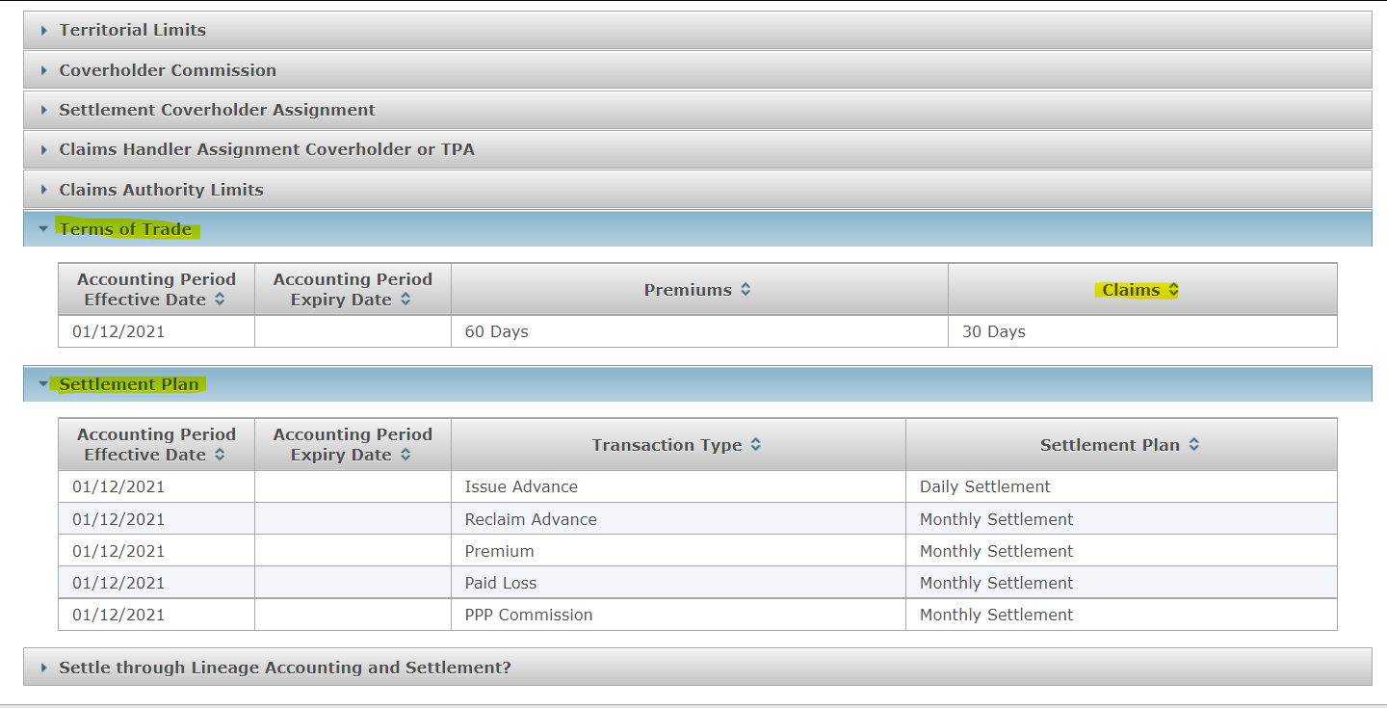
6th January 2023 – Payment processed/approved. Terms of trade is 30 days. Payment will be settled on 28th February 2023

Accounting Month
On the Lineage application, the closure of an accounting month is based on the set Scheme Canada Calendar and this date is always the second business day of the following month i.e. January 2023 accounting month will be closed on 2nd February 2023. Any claim payment reported and approved by 2nd February will fall on the January 2023 Accounting month reports and settled at the end of February if the Terms of Trade was 30 days.
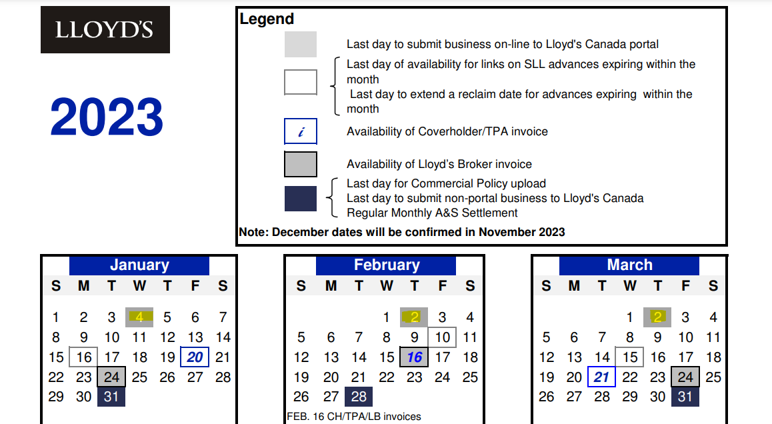

I-Items – Example
- A request was made by underwriters for an individual claim entry on 24th January 2023.
- The first check made is the Terms of Trade for claims as per the binding authority slip. This is also shown on the binding authority level in lineage. In this instance the terms of trade for claims was 30 days.
- 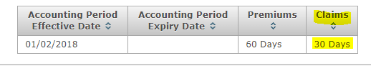
- If the term of trade is greater than 30 days then payments will be pushed forward by one calendar month per extra 30 days added. For example, for 60 days terms of trade a payment would be pushed into the next month’s calendar extract period and uploaded into XCS CLASS one month later than for the usual 30 days terms of trade cases.
- In this example, at the time of set up on 24th January 2023, the last bordereau extract from Lineage into XCS CLASS would have been at the end of December 2022, that is the November 2022 extract period.
- The extract period for the November 2022 bordereau ran from 3rd November up to and including 2nd December 2022.
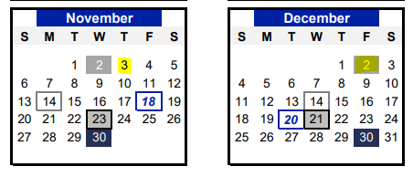

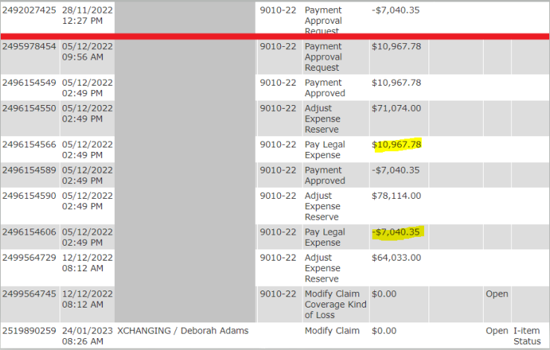
- Any payment/refund made on or after 3rd December 2022 was therefore be discounted from the paid to date calculation and included under the outstanding reserve as it will not yet have been transacted in XCS CLASS.

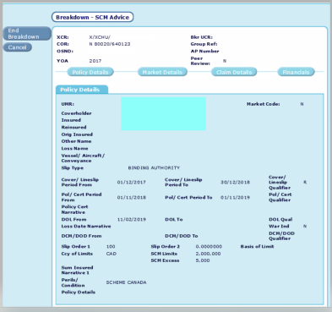
- The individual class entry was created using all the unique claim details and a positive financial movement is noted moving the paid and outstanding reserves under its own claim office reference (C.O.R)

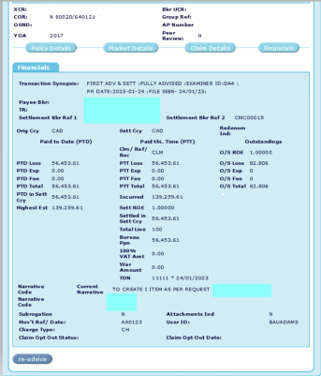

- A second transaction was then made in XCS class under the block claims office reference (C.O.R.) and the outstanding reserve and the paid to date was reduced accordingly.
- Lineage was updated to show the new claims office reference (C.O.R.) for the individual class entry.
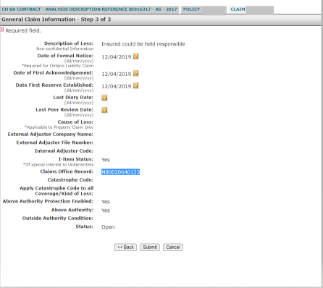

- The lineage entry is now an individual (I Item)
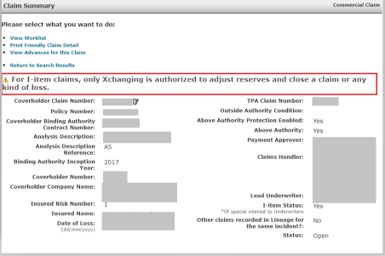

Claims Payments processed in Lineage
How payments are handled:
- Regular Claims payments
  - These payments are processed either by a Coverholder or a TPA and settled within the set Terms of Trade indicated on the Binding Authority Coverholder Terms.
  - Payments are settled on the month end Invoice of the respective Organisations

- Above Authority payments
  - These payments are processed either by a Coverholder or a TPA and settled within the set Terms of Trade indicated on the Binding Authority Coverholder Terms.
  - These payments have to be approved by the Lloyd’s Broker on behalf of the Underwriter(s) or in certain cases for certain Service Companies, the payments are approved by the Underwriter

- Scheme Canada Payments
  - There are 2 Types of Scheme Advances
    - Single Large Loss – these payments are requested on a particular claim and settled within 4-6 days from the time they are approved by Xchanging or in certain cases the Underwriter.
    - Non-Deductible Floats (Loss funds) – these payments are requested against a Coverholder Contract and settled within 4-6 days from the time they are approved by Xchanging or in certain cases the Underwriter.
    - Advances approved as Loss funds start with 999 and Single Large Loss start with 997
    - All Scheme Advances have a reclaim date. If not reported against the claim or replenished in Loss funds, they are reclaimed and returned to the respective Underwriters.
    - These payments are requested when the Coverholder/TPA does not have the funds based on their claim limit agreement, in some cases payment needs to be settled to Lawyers, etc.

Roles & Responsibilities
TELUS
TELUS is a service provider to Lloyd’s Canada, Inc
- TELUS is responsible for maintaining the Lineage application
- TELUS is responsible for generating the Reports and Settlement Invoices to Lloyd’s Stakeholders
- TELUS is responsible for updating any changes on the Lineage application upon sign off from Lloyd’s Canada
- TELUS is responsible for providing Lineage training to Lloyd’s Stakeholders

Contact Details…
Contact us for further clarification/ guidance or to arrange a training session on the Lloyd’s Canada Portal (Lineage)…
Canada
Lloyd’s Canada Service Desk
Telephone: +1 514 864 5444 (from UK)
1 877 455 6937 (from North America) or 1 877 (4LLOYDS)
Email: info@lloyds.ca
8.30am – 17.00pm (Eastern Standard Time)

For suggestions/future changes on Lineage
Email can be sent to:
Patrick Hayes
Head of Operations, Americas
Lloyd’s
Telephone: 514 864 5445
From UK dial: +44 207 327 7143
Email: Patrick.Hayes@lloyds.com

Roles & Responsibilities
Xchanging Claims Services
- Scheme Canada processing is recognised as an enhanced Technical Processing Service provided by XCS.
- XCS is not an agreement party in this context.
- XCS will complete rudimentary checks in both Lineage and ECF i.e., has the correct OSN&D/ Risk Code been used etc., and will ensure the required authority has been obtained. XCS will also ensure the transactions entered into Lineage are in accordance with the ECF file. Any discrepancies will be raised.
- XCS will check that payments authorised by Underwriters have been settled in Lineage; again, any discrepancies will be raised.
- Lloyd’s have agreed the data submitted via the Lineage portal supersedes data held in CLASS. The data submitted in the monthly bdx will therefore NOT be checked by XCS in advance of the upload to CLASS.
- XCS are responsible for completing XCS CLASS records for all Scheme Canada advances which have been approved in Lineage by third parties (where Syndicates have other approval arrangements but still require CLASS records).
- The Scheme Canada Team in XCS provide daily support to the market in addition to the day-to-day processing.

Claims Reports
Summary of Claim Reports generated by Lloyd’s Canada (Lineage application)

Report Name | Availability (Business Days) | Format | Report Description
Claims Analysis - Claims History (Drilldown Data Export)  &  Claims Analysis - Data Extracts - Claims History | 6th | Dashboard | Provides “as at” details of all open and closed claims on a Binding Authority and caters to those stakeholders who require the details of all claim activity for a Binding Authority contract. These details can be used to support e.g., profit commission calculations, analyses and preparation for BA renewal discussions. The report will provide the “as at” picture for any or all claims as well as the ability to track the life cycle of a particular claim.
Claims Analysis - Claims Movement (Drilldown Data Export)  &  Claims Analysis - Data Extracts - Claims Movement | 4th | Dashboard | Allows to readily identify the quantum and detail of claim movements that occurred in the latest reporting month, thus focusing attention on business activity (for Binding Authorities classified “Lineage Accounting & Settlement” where FDO details have been received and applied by Lloyd’s Canada).
Claims Monthly Extract | 20th | CSV | Monthly: Approved Claim transactions recorded by Coverholders and TPAs for the current accounting month including all the transactions being settled in the current month based on the Terms of trade indicated on the Binding Authority.
Claims per Binding Authority | 6th | CSV | List of in-force claims within a Binding Authority Contract (claim level). The report includes all open and closed claims related to Binding Authority Contracts effective in the last 7 years (i.e., current Reporting period minus 7). For older Binding Authority Contracts, the report shows all open and closed claims where at least one claim is still opened or has been reopened.
Claims Reconciliation | 8th | CSV | Aggregated Claim Reconciliation Transactions registered including transactions that are not yet showing in the Xchanging CLASS system. Information aggregated at the claim level, with a total by FDO Block/ I-Item. Report is used to reconcile between Lineage and CLASS.
Claims Weekly Extract | During the first business day of each week | CSV | Weekly: Approved payments, advances and reclaims settled since the last time the report was produced. The report will exclude payments to date figures and outstanding and current reserve information.
Daily Claims Reconciliation | Daily | CSV | Daily Claim transactions reported on the application. Information is cumulative and contains all transactions entered, regardless of effective date, from the first day to the last day of an accounting month. Data includes information for the last 3 months.
Daily Premium Reconciliation | Daily | CSV | Daily Premium transactions reported on the application. Information is cumulative and contains all transactions entered, regardless of effective date, from the first day to the last day of an accounting month. Data includes information for the last 3 months.
Executive Dashboard - Data Extracts - Binding Authority Analysis | 4th | Dashboard | Allows user to create tailored report relating to Gross Written Premium and Incurred Claims for A&S business where the FDO signing details have been received and attached to the respective Contracts/UMRs
Executive Dashboard - Data Extracts - League Tables | 4th | Dashboard | Allows to create ranking report base on specific numbers of stakeholders for A&S business where the FDO signing details have been received and attached to the respective Binding Authority Contracts/UMRs.
Executive Dashboard - Data Extracts - Stakeholder Relationships | 4th | Dashboard | Allows users to determine which Lloyd's Brokers are doing business with which Syndicates or which Coverholders (and vice versa) and how much business is being conducted which each pair for A&S business where the FDO signing details have been received and attached to the respective Binding Authority Contracts/UMRs.
Executive Dashboard - GWP / Incurred Claims  - Risk Code Grouping  - Risk Province/ Region  - Year of Account  Executive Dashboard - League Tables  - Top League Tables  Executive Dashboard - Incurred Claims Only  - Risk Code Grouping  - Risk Province/Region  - Year of Account | 4th | Dashboard | Provides the ability to obtain a visual representation of high-level metrics on premiums and claims by Year of Account, Risk Province/Region, Line of Business and Risk Code Grouping across a book of business, to obtain a high-level view of its performance (for Binding Authorities classified “Lineage Accounting & Settlement” where FDO details have been received and applied by Lloyd’s Canada).  The Information is broken down into 3 categories of Business Analysis:  Gross Written Premium / Incurred Claims - provides a choice of paths for the breakdown of Gross Written Premium and Incurred Claims through which to obtain a deeper drill down.  Incurred Claims Only - provides the breakdown of reserves and paid losses split by the 3 components: indemnity, expenses, and fees.  Leagues Tables - these tables rank by Gross Written Premium the Lloyd's Brokers or Syndicates conducting business through.
IBC Regulatory Reporting - Data Extracts - IBC Claims | between 7th-11th (except 20th December) | Dashboard | List of Binding Authority transactions not settled via Lineage (used to monitor/reconcile the regulatory business Coverholders/Third Party Administrators are obliged to report to Lloyd's Canada - Commercial Ontario Liability and Automobile).
IBC Regulatory Reporting - Data Extracts - IBC Risks | between 7th-11th (except 20th December) | Dashboard | List of Binding Authority transactions not settled via Lineage (used to monitor/reconcile the regulatory business Coverholders are obliged to report to Lloyd's Canada - Commercial Ontario Liability and Automobile).
Monthly Transactions - Data Extracts - Claims Excluding Settlement - All Transactions | 4th | Dashboard | List of ALL approved claim payments including reserves processed during the accounting months. The Planned Settlement date is not indicated.
Monthly Transactions - Data Extracts - Claims Excluding/Including Settlement - Open Claims | 4th | Dashboard | Details for all open claims/kinds of loss/claimant as at the applicable accounting period. This report will eventually replace the standard report Open Claims (PDF version).
Monthly Transactions - Data Extracts - Claims Excluding/Including Settlement - Payment Transactions | 4th | Dashboard | Details the paid claims, including those identified as paid from a single large loss advance submitted by Coverholders and TPAs (regardless of whether or not the FDO details have been received and applied by Lloyd’s Canada). Information is for the applicable accounting period. This report will eventually replace the standard report Paid Loss (PDF version).
Monthly Transactions - Data Extracts - Claims Including Settlement - All Transactions | 20th | Dashboard | List of ALL approved claim payments including reserves processed during the accounting months. The Planned Settlement date is indicated.

Glossary
XCS | Xchanging Claims Services
SCM | Syndicate Claims Message
PTD | Paid to date
CLASS | Claims Loss Advice & Settlement System
OSN&D | Original Signing Number and Date
O/S | Outstanding
COR | Claim Office Record
I-Item | Item of Interest
UW | Underwriter
CH | Coverholder
TPA | Third Party Administrator
LB | Lloyd’s Broker
TDN | Take Down Number
API | Application Programming Interface
DCA | Delegated Claims Administrator

